1. **Introduction:**

[**https://www.conduktor.io/kafka/what-is-apache-kafka/**](https://www.conduktor.io/kafka/what-is-apache-kafka/)

à Before Kafka if you want to store some data from source system to target system it was easy but, as your project grows there are numbers of source system and target system that needs to transfer and store data with each other. With this the application becomes very complicated.

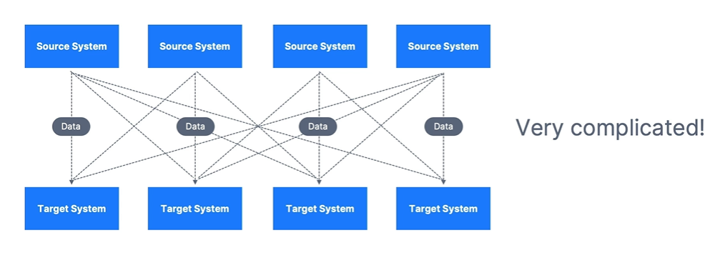

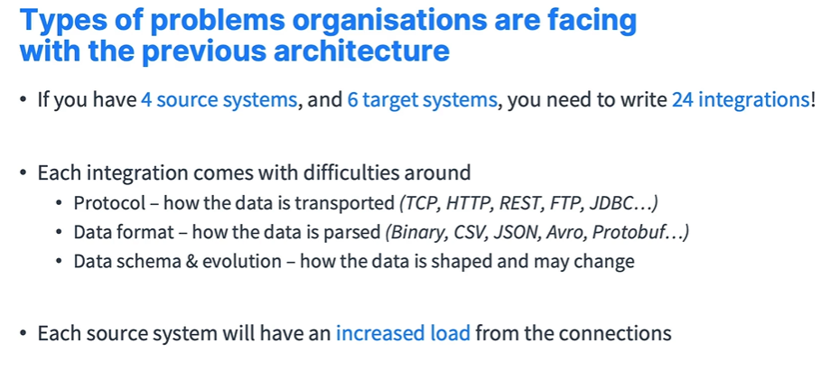

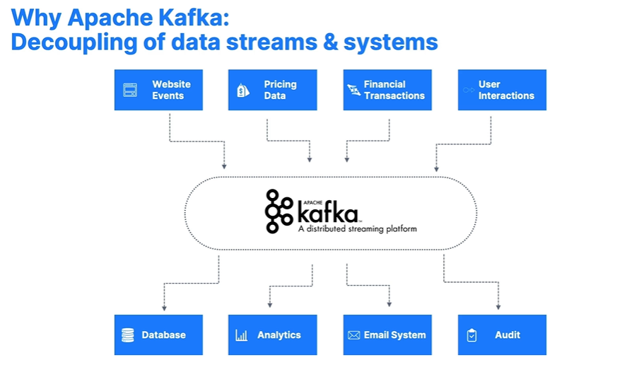

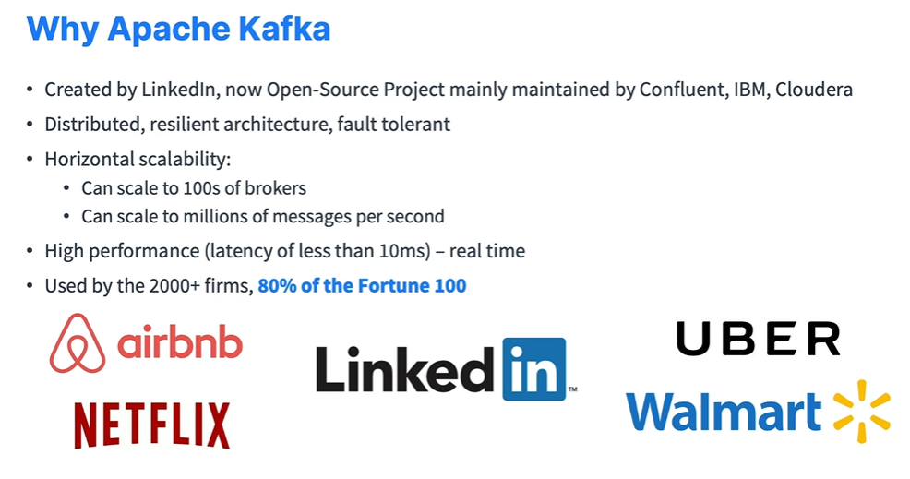

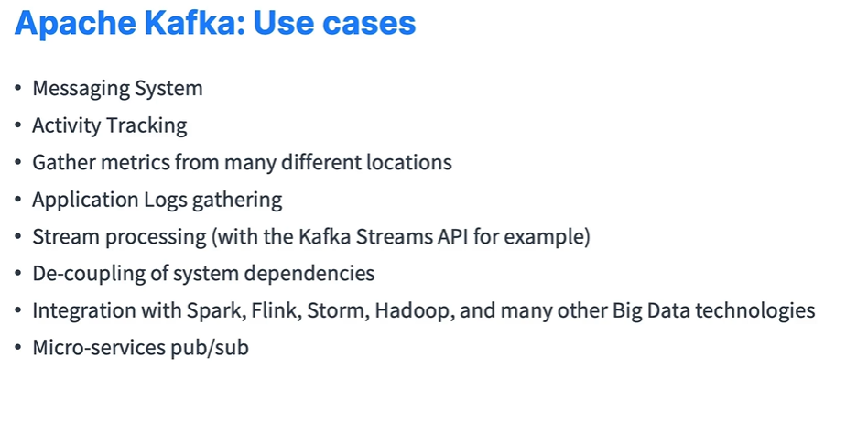

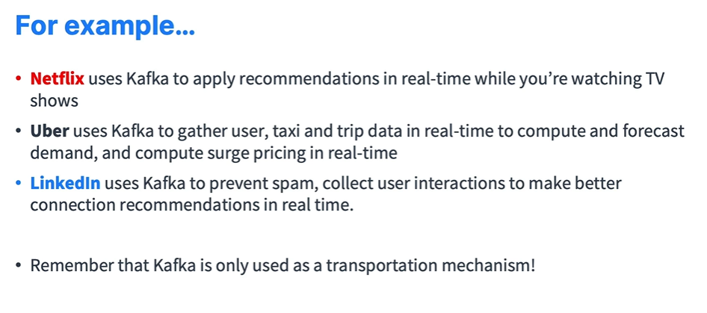

* 1. **What is event streaming?**

à Technically speaking, event streaming is the practice of capturing data in real-time from event sources like databases, sensors, mobile devices, cloud services, and software applications in the form of streams of events; storing these event streams durably for later retrieval manipulating, processing, and reacting to the event streams in real-time as well as retrospectively and routing the event streams to different destination technologies as needed. Event streaming thus ensures a continuous flow and interpretation of data so that the right information is at the right place, at the right time.

* 1. **What can I use event streaming for?**

à Event streaming is applied to a [wide variety of use cases](https://kafka.apache.org/powered-by) across a plethora of industries and organizations. Its many examples include:

* To process payments and financial transactions in real-time, such as in stock exchanges, banks, and insurances.
* To track and monitor cars, trucks, fleets, and shipments in real-time, such as in logistics and the automotive industry.
* To continuously capture and analyse sensor data from IoT devices or other equipment, such as in factories and wind parks.
* To collect and immediately react to customer interactions and orders, such as in retail, the hotel and travel industry, and mobile applications.
* To monitor patients in hospital care and predict changes in condition to ensure timely treatment in emergencies.
* To connect, store, and make available data produced by different divisions of a company.
* To serve as the foundation for data platforms, event-driven architectures, and microservices.
  1. **Apache Kafka® is an event streaming platform. What does that mean?**

à Kafka combines three key capabilities so you can implement your use cases for event streaming end-to-end with a single battle-tested solution:

* To publish (write) and subscribe to (read) streams of events, including continuous import/export of your data from other systems.
* To store streams of events durably and reliably for as long as you want.
* To process streams of events as they occur or retrospectively.

à All this functionality is provided in a distributed, highly scalable, elastic, fault-tolerant, and secure manner. Kafka can be deployed on bare-metal hardware, virtual machines, and containers, and on-premises as well as in the cloud. You can choose between self-managing your Kafka environments and using fully managed services offered by a variety of vendors.

* 1. **How does Kafka work in a nutshell?**

à Kafka is a distributed system consisting of servers and clients that communicate via a high-performance TCP network protocol. It can be deployed on bare-metal hardware, virtual machines, and containers in on-premises as well as cloud environments.

à **Servers:** Kafka run as a cluster of one or more servers that can span multiple datacentres or cloud regions. Some of these servers form the storage layer, called the brokers. Other servers run Kafka Connect to continuously import and export data as event streams to integrate Kafka with your existing systems such as relational databases as well as other Kafka clusters. To let you implement mission-critical use cases, a Kafka cluster is highly scalable and fault-tolerant: if any of its servers fails, the other servers will take over their work to ensure continuous operations without any data loss.

à **Clients:** They allow you to write distributed applications and microservices that read, write, and process streams of events in parallel, at scale, and in a fault-tolerant manner even in the case of network problems or machine failures. Kafka ships with some such clients included, which are augmented by dozens of clients provided by the Kafka community: clients are available for Java and Scala including the higher-level Kafka Streams library, for Go, Python, C/C++, and many other programming languages as well as REST APIs.

* 1. **Main Concepts and Terminology?**

à An event records the fact that "something happened" in the world or in your business. It is also called record or message in the documentation. When you read or write data to Kafka, you do this in the form of events. Conceptually, an event has a key, value, timestamp, and optional metadata headers. Here's an example event:

* Event key: "Alice".
* Event value: "Made a payment of $200 to Bob".
* Event timestamp: "Jun. 25, 2020, at 2:06 p.m.".

à **Producers** are those client applications that publish (write) events to Kafka, and **Consumers** are those that subscribe to (read and process) these events. In Kafka, producers and consumers are fully decoupled and agnostic of each other, which is a key design element to achieve the high scalability that Kafka is known for. For example, producers never need to wait for consumers. Kafka provides various guarantees such as the ability to process events exactly-once.

à Events are organized and durably stored in **Topics**. Very simplified, a topic is like a folder in a filesystem, and the events are the files in that folder. An example topic name could be "payments". Topics in Kafka are always multi-producer and multi-subscriber, a topic can have zero, one, or many producers that write events to it, as well as zero, one, or many consumers that subscribe to these events. Events in a topic can be read as often as needed unlike traditional messaging systems, events are not deleted after consumption. Instead, you define for how long Kafka should retain your events through a per-topic configuration setting, after which old events will be discarded. Kafka's performance is effectively constant with respect to data size, so storing data for a long time is perfectly fine.

à Topics are **partitioned**, meaning a topic is spread over several "buckets" located on different Kafka brokers. This distributed placement of your data is very important for scalability because it allows client applications to both read and write the data from/to many brokers at the same time. When a new event is published to a topic, it is appended to one of the topic's partitions. Events with the same event key (e.g., a customer or vehicle ID) are written to the same partition, and Kafka guarantees that any consumer of a given topic-partition will always read that partition's events in the same order as they were written.

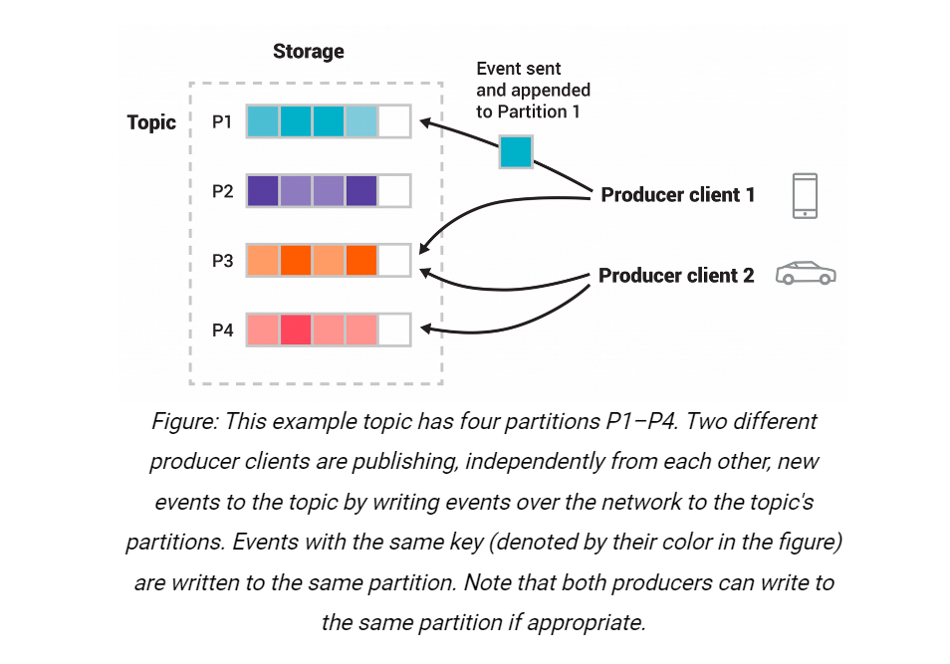

à To make your data fault-tolerant and highly available, every topic can be replicated, even across geo-regions or datacentres, so that there are always multiple brokers that have a copy of the data just in case things go wrong, you want to do maintenance on the brokers, and so on. A common production setting is a replication factor of 3, i.e., there will always be three copies of your data. This replication is performed at the level of topic-partitions.

* 1. **Kafka APIs:**

à In addition to command line tooling for management and administration tasks, Kafka has five core APIs for Java and Scala:

* The **Admin API** to manage and inspect topics, brokers, and other Kafka objects.
* The **Producer API** to publish (write) a stream of events to one or more Kafka topics.
* The **Consumer API** to subscribe to (read) one or more topics and to process the stream of events produced to them.
* The Kafka **Streams API** to implement stream processing applications and microservices. It provides higher-level functions to process event streams, including transformations, stateful operations like aggregations and joins, windowing, processing based on event-time, and more. Input is read from one or more topics to generate output to one or more topics, effectively transforming the input streams to output streams.
* The Kafka **Connect API** to build and run reusable data import/export connectors that consume (read) or produce (write) streams of events from and to external systems and applications so they can integrate with Kafka. For example, a connector to a relational database like PostgreSQL might capture every change to a set of tables. However, in practice, you typically don't need to implement your own connectors because the Kafka community already provides hundreds of ready-to-use connectors.
  1. **Use Cases:**

à **Messaging:** Kafka works well as a replacement for a more traditional message broker. Message brokers are used for a variety of reasons (to decouple processing from data producers to buffer unprocessed messages, etc). In comparison to most messaging systems Kafka has better throughput, built-in partitioning, replication, and fault-tolerance which makes it a good solution for large scale message processing applications. Messaging uses are often comparatively low throughput but may require low end-to-end latency and often depend on the strong durability guarantees Kafka provides. In this domain Kafka is comparable to traditional messaging systems such as ActiveMQ or RabbitMQ.

à **Website Activity Tracking:** The original use case for Kafka was to be able to rebuild a user activity tracking pipeline as a set of real-time publish-subscribe feeds. This means site activity (page views, searches, or other actions users may take) is published to central topics with one topic per activity type. These feeds are available for subscription for a range of use cases including real-time processing, real-time monitoring, and loading into Hadoop or offline data warehousing systems for offline processing and reporting. Activity tracking is often very high volume as many activity messages are generated for each user page view.

à **Metrics:** Kafka is often used for operational monitoring data. This involves aggregating statistics from distributed applications to produce centralized feeds of operational data.

à **Log Aggregation:** Many people use Kafka as a replacement for a log aggregation solution. Log aggregation typically collects physical log files off servers and puts them in a central place (a file server or HDFS perhaps) for processing. Kafka abstracts away the details of files and gives a cleaner abstraction of log or event data as a stream of messages. This allows for lower-latency processing and easier support for multiple data sources and distributed data consumption. In comparison to log-centric systems like Scribe or Flume, Kafka offers equally good performance, stronger durability guarantees due to replication, and much lower end-to-end latency.

à **Stream Processing:** Many users of Kafka process data in processing pipelines consisting of multiple stages, where raw input data is consumed from Kafka topics and then aggregated, enriched, or otherwise transformed into new topics for further consumption or follow-up processing. For example, a processing pipeline for recommending news articles might crawl article content from RSS feeds and publish it to an "articles" topic, further processing might normalize or deduplicate this content and publish the cleansed article content to a new topic; a final processing stage might attempt to recommend this content to users. Such processing pipelines create graphs of real-time data flows based on the individual topics. Starting in 0.10.0.0, a lightweight but powerful stream processing library called Kafka Streams is available in Apache Kafka to perform such data processing as described above. Apart from Kafka Streams, alternative open-source stream processing tools include Apache Storm and Apache Samza.

à **Event Sourcing:** Event sourcing is a style of application design where state changes are logged as a time-ordered sequence of records. Kafka's support for very large, stored log data makes it an excellent backend for an application built in this style.

à **Commit Log:** Kafka can serve as a kind of external commit-log for a distributed system. The log helps replicate data between nodes and acts as a re-syncing mechanism for failed nodes to restore their data. The log compaction feature in Kafka helps supports this usage. In this usage Kafka is like Apache Bookkeeper project.

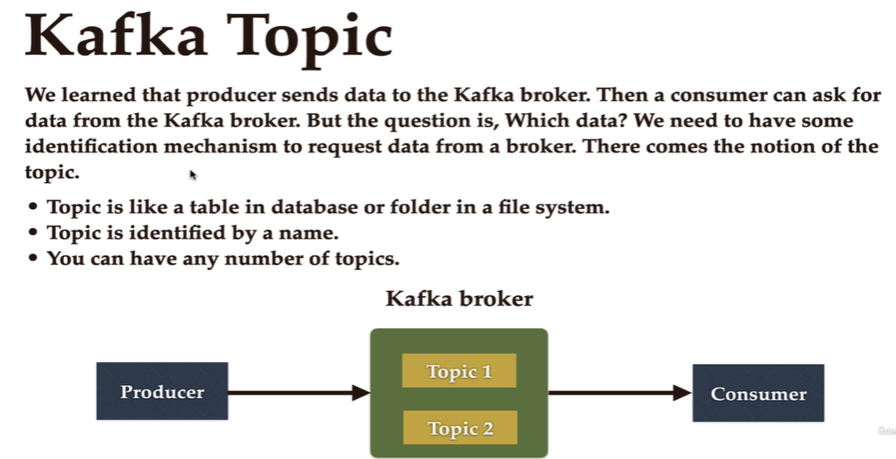

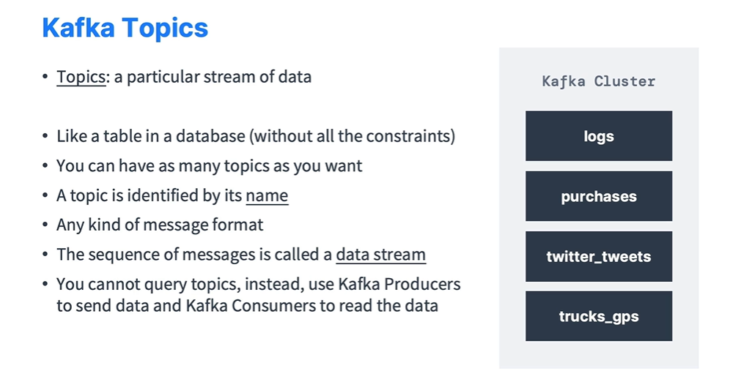

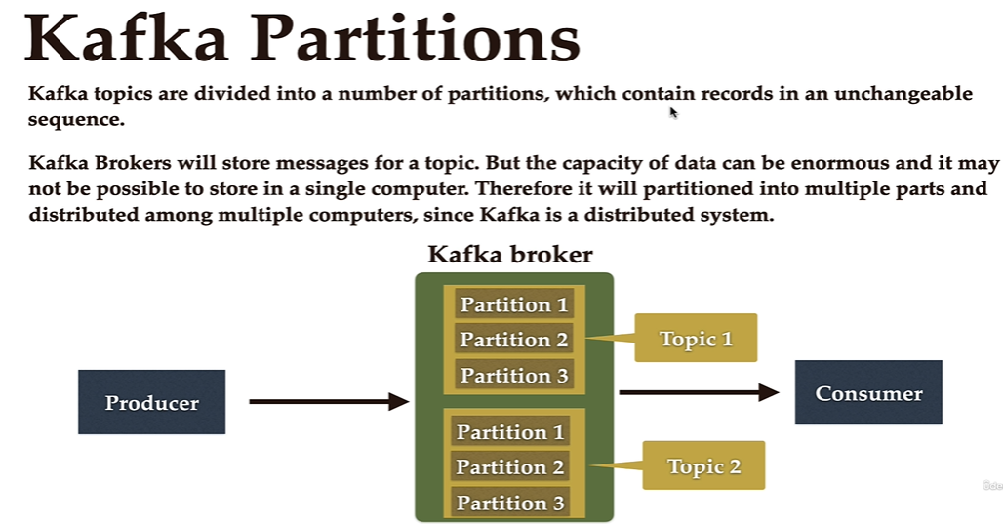

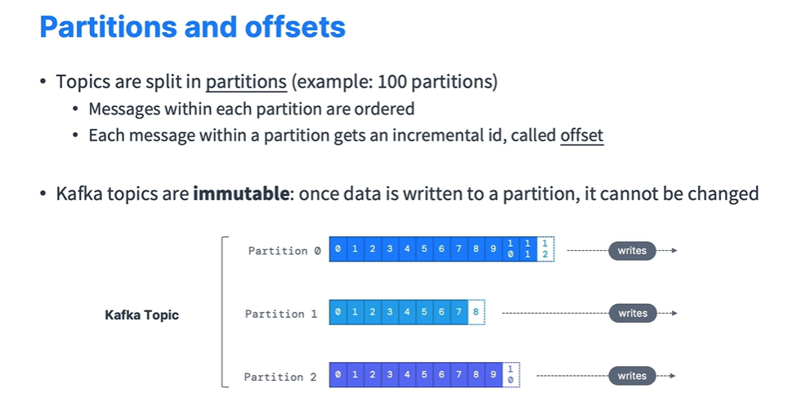

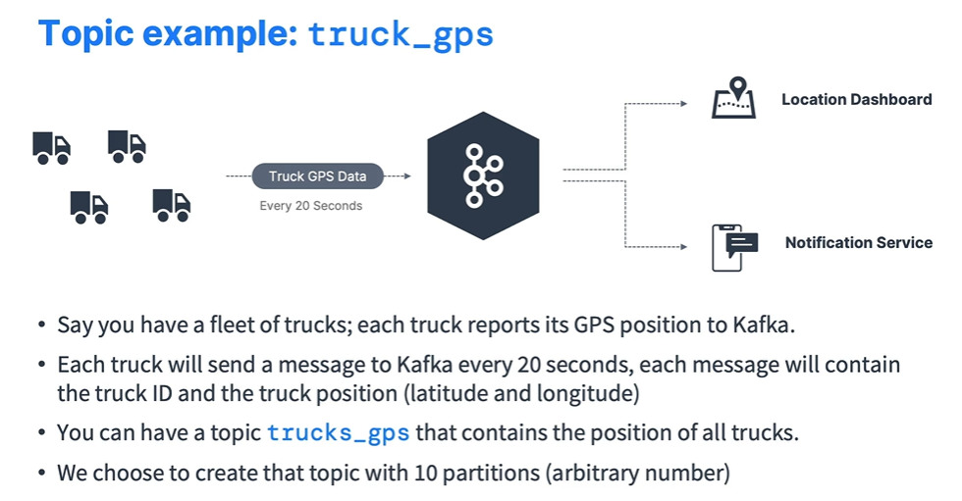

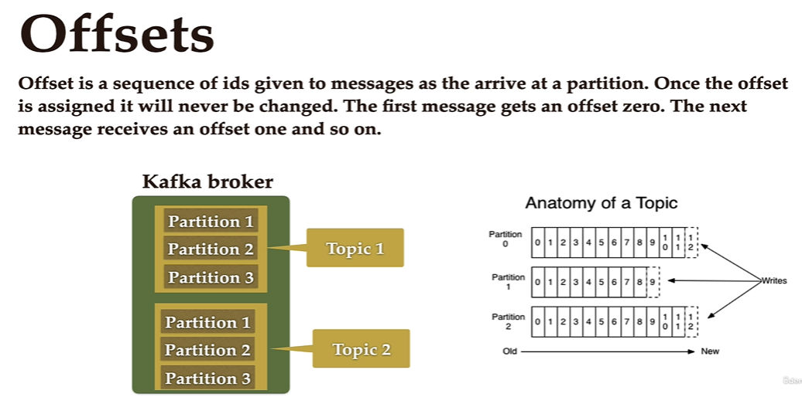

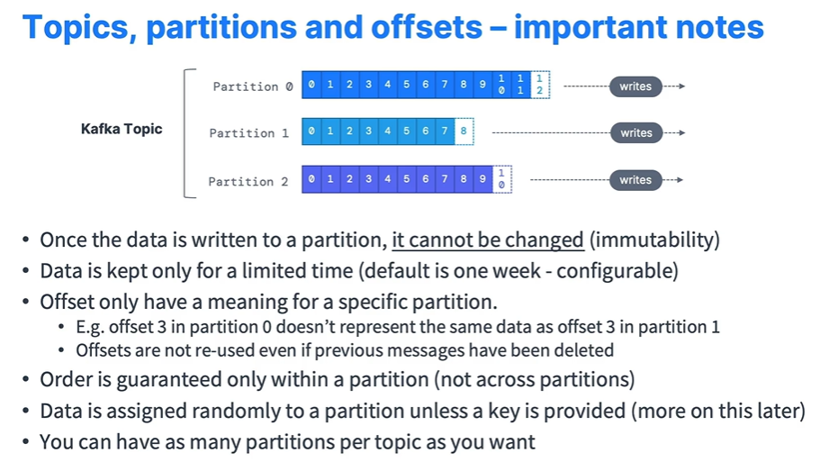

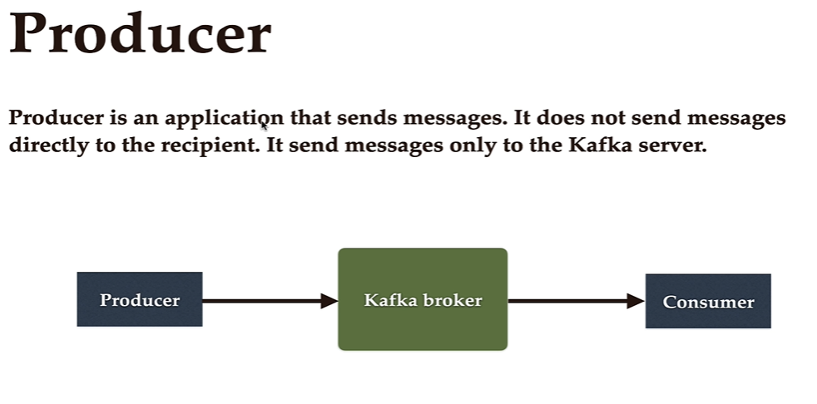

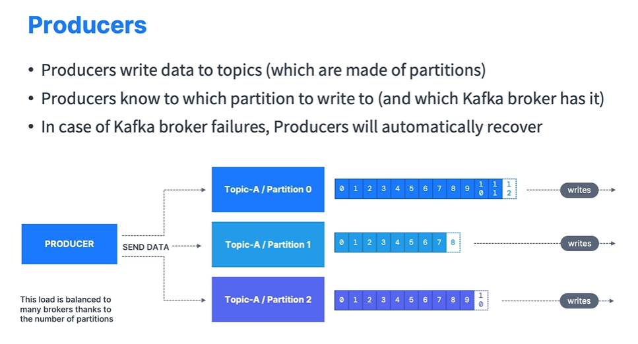

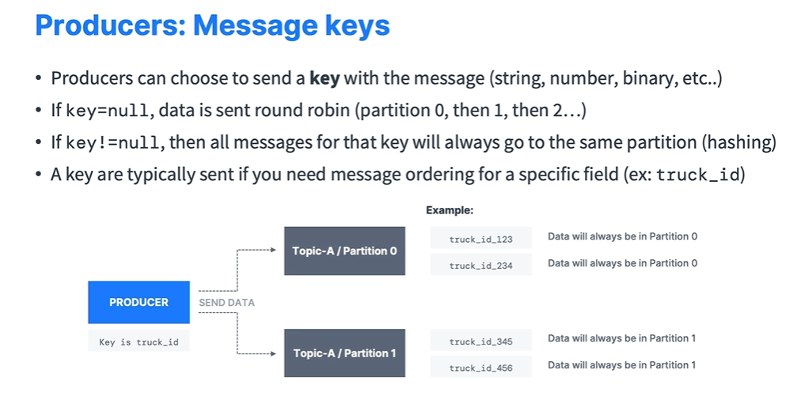

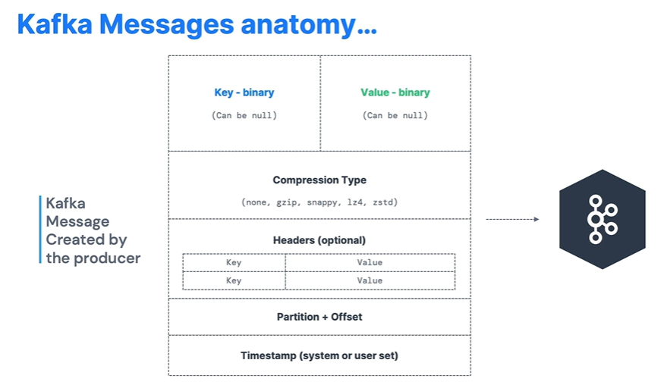

High Throughput Producer:

* We’ll add snappy message compression in our producer.
* Snappy is very helpful if your messages are text based, for example log lines pr JSON documents.
* Snappy has good balance of CPU/compression ratio.
* We’ll also increase the batch.size to 32KB and introduce a small delay through linger.ms(20MS).
* ProducerConfig.COMPRESSION_TYPE_CONFIG = “snappy”

ProducerConfig.LINGER_MS_CONFIG = “20ms”

ProducerConfig.BATCH_SIZE_CONFIG = “32*1024”

Sticky Partitioner:

* It would be better to have all the records sent to a single and not multiple partitions to improve batching.
* We stick to a partition until the batch is full or linger.ms has elapsed.
* Larger batches and reduced latency.

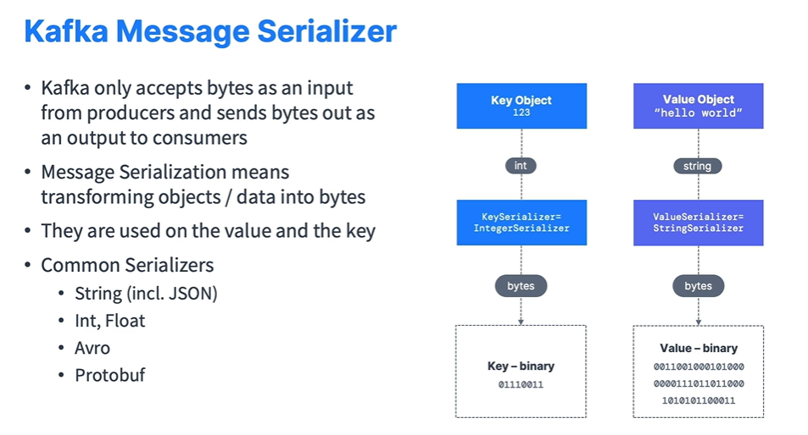

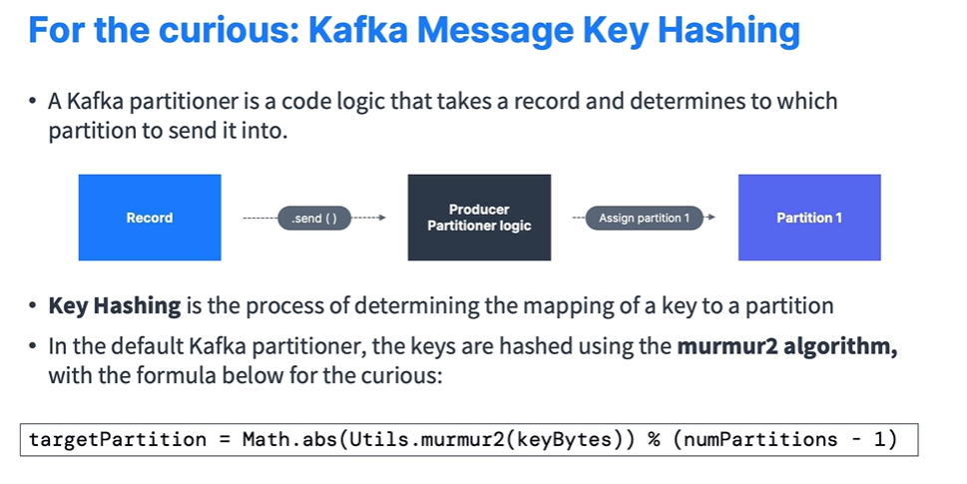

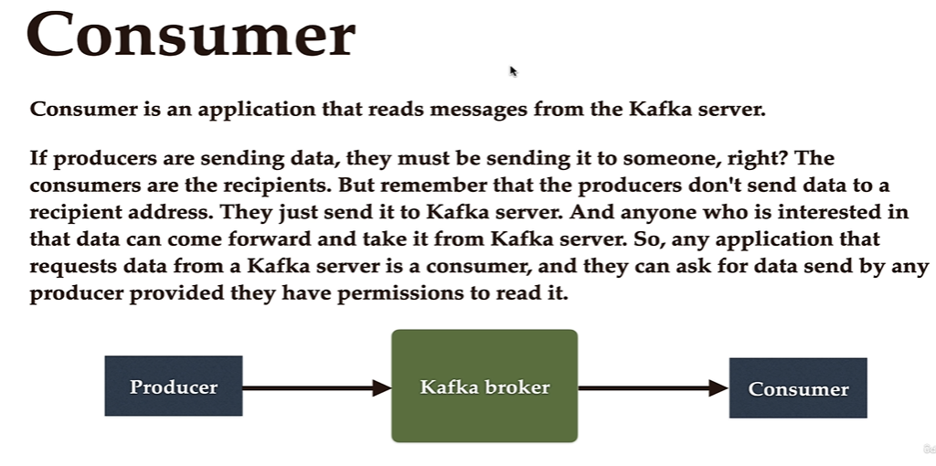

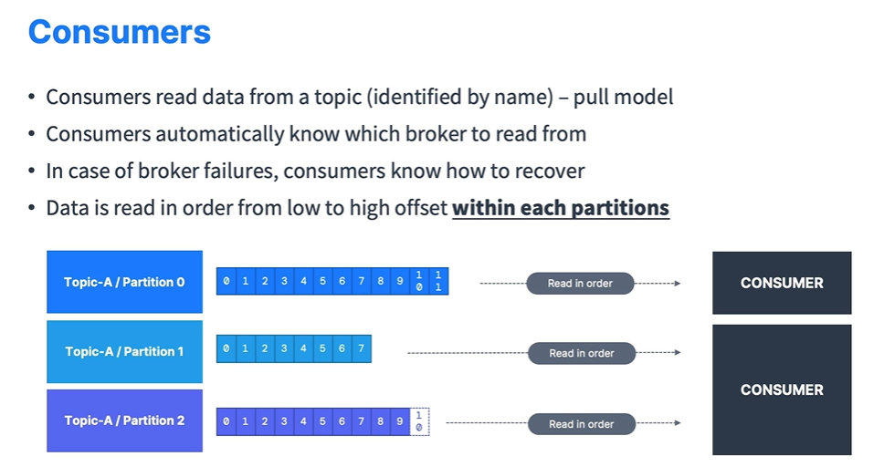

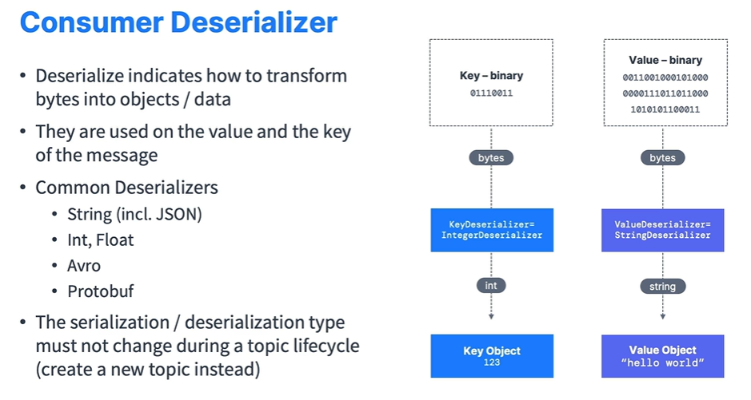

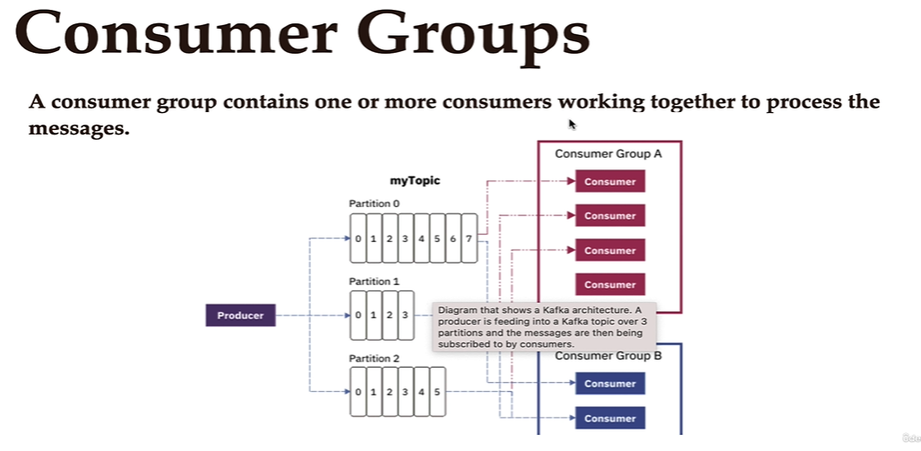

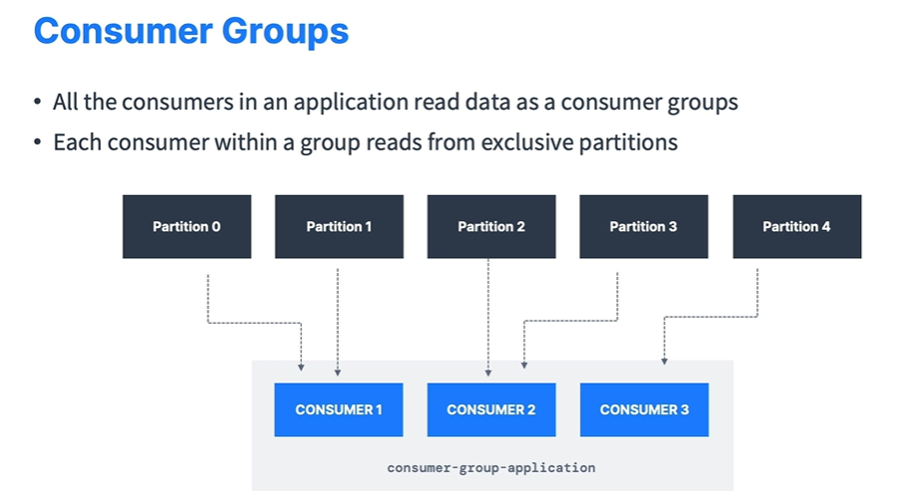

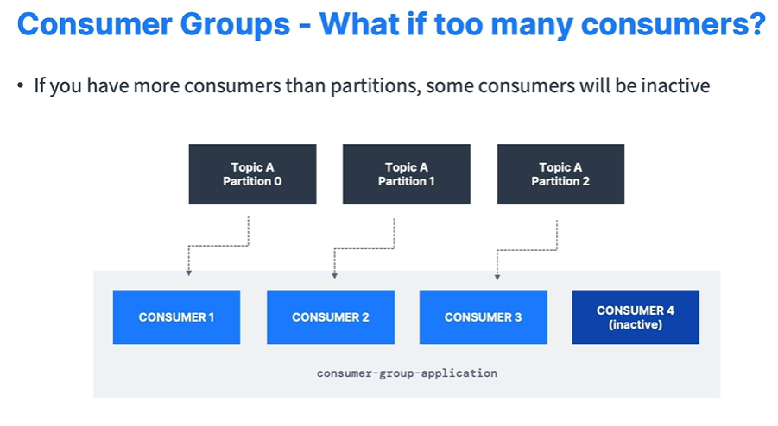

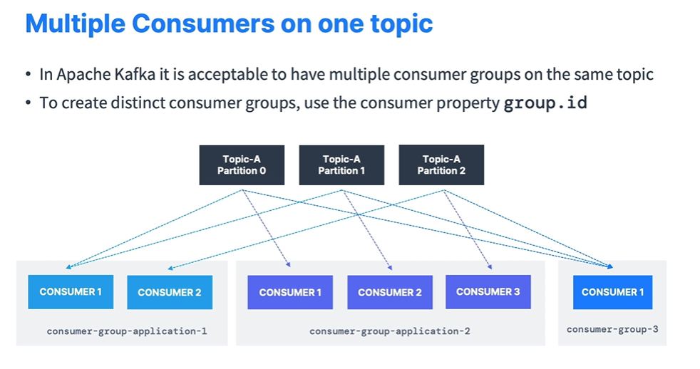

Consumer Heartbeat Thread to Find out if consumer is down or not.

* Heartbeat.interval.ms: (default is 3ms).
* Session.timeout.ms: (default 45 seconds).
  + If no heartbeats are sent during this period, then the consumer considered dead.
  + Set even lower to faster consumer rebalances.

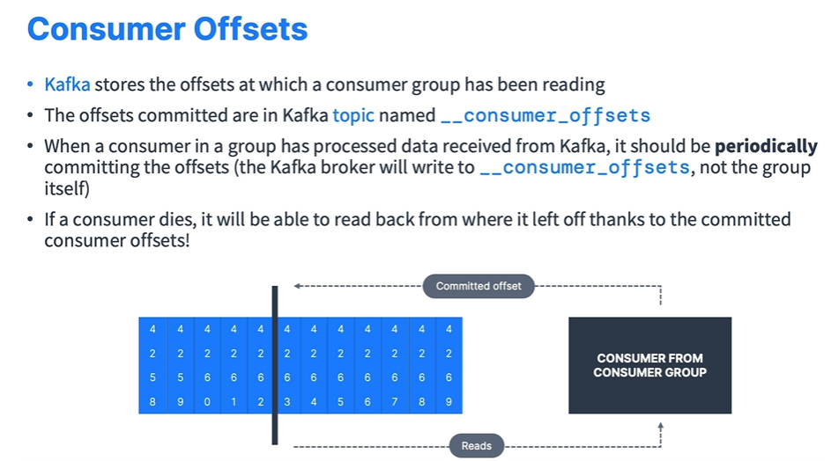

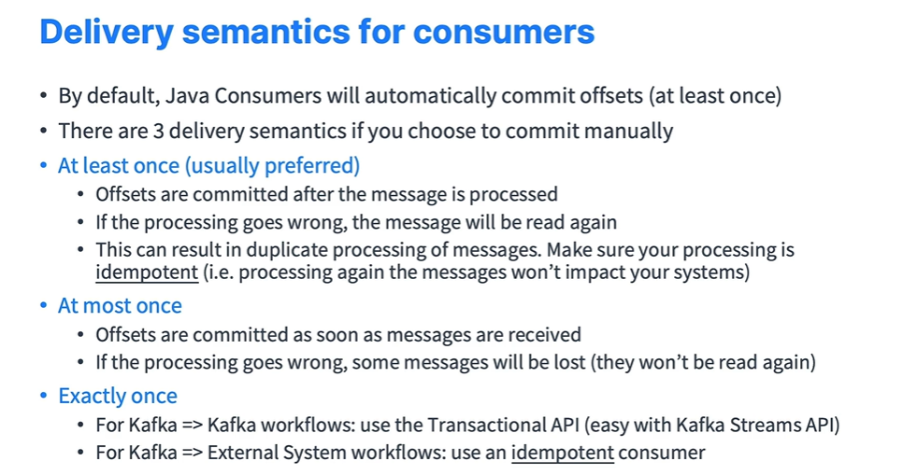

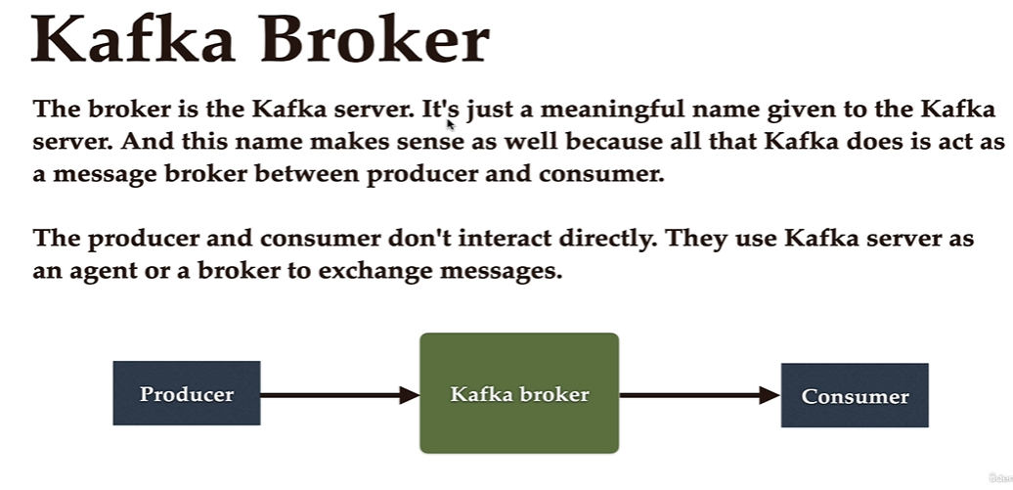

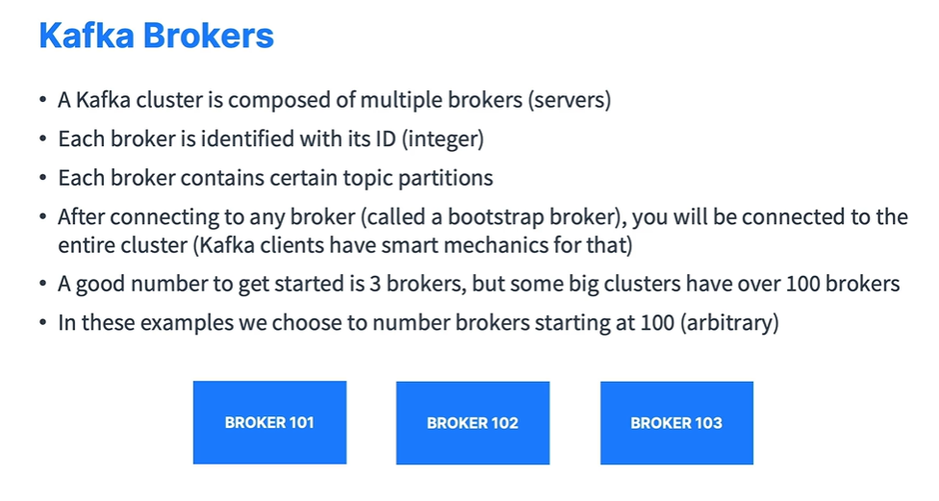

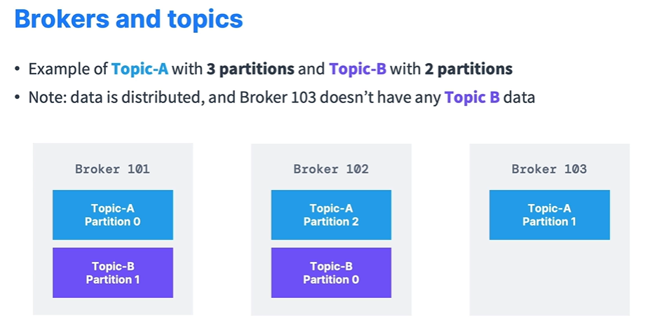

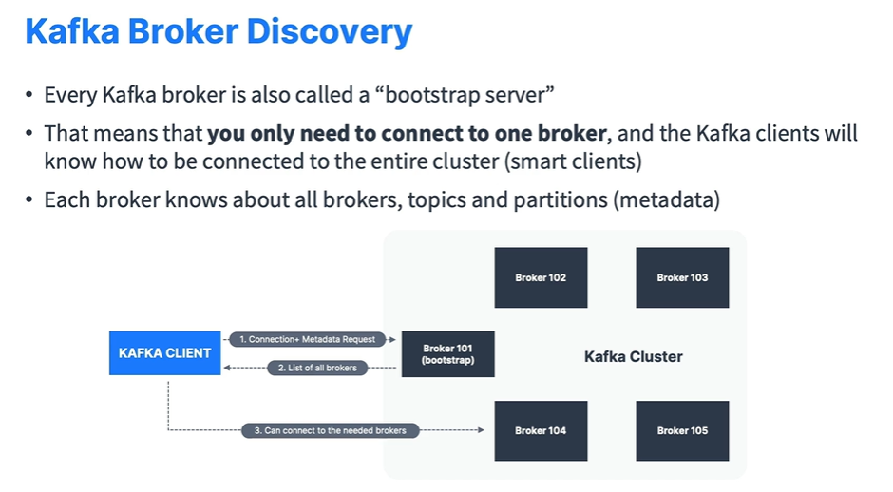

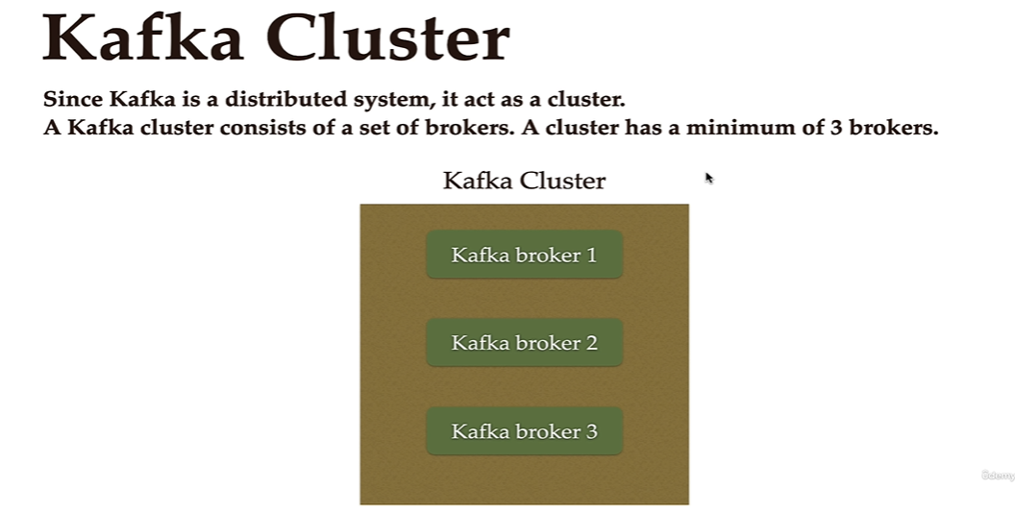

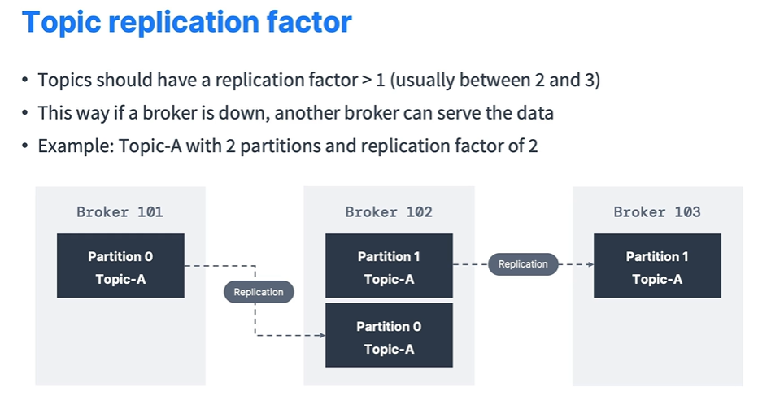

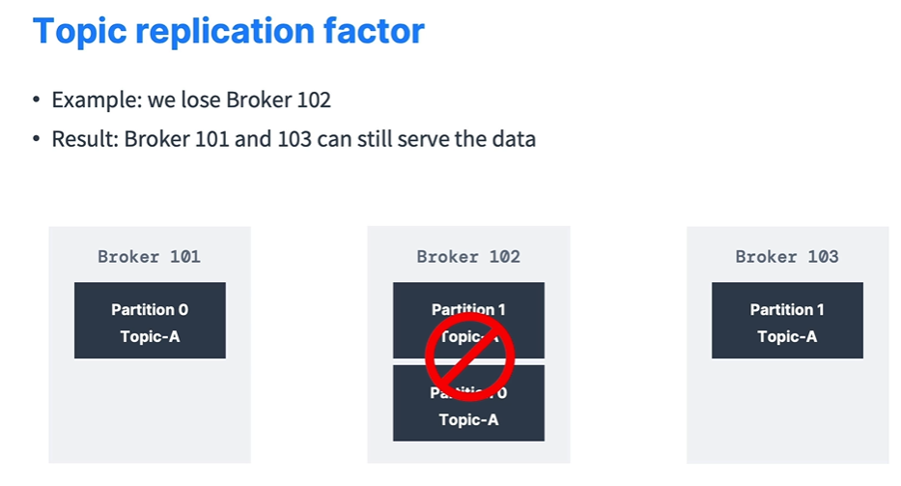

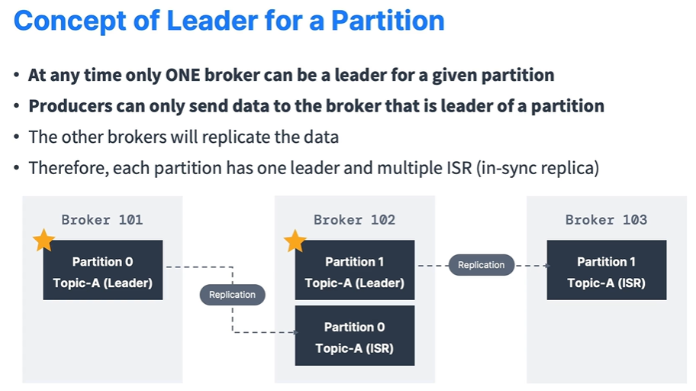

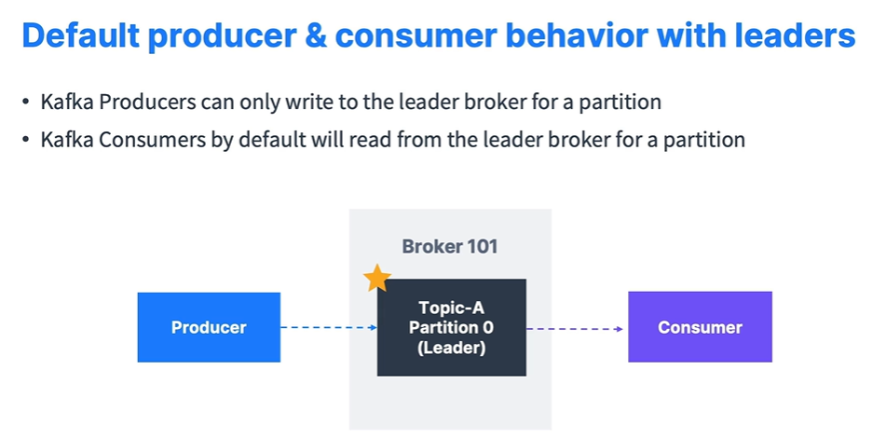

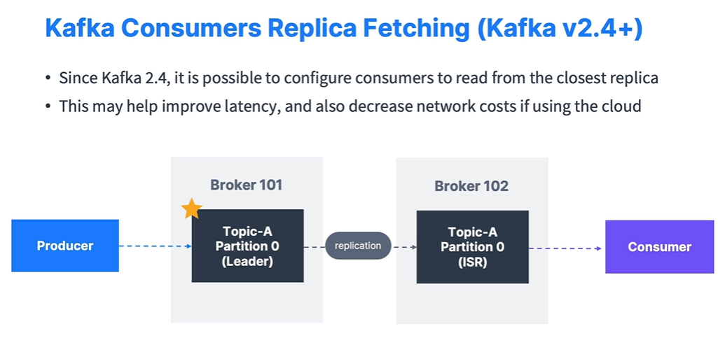

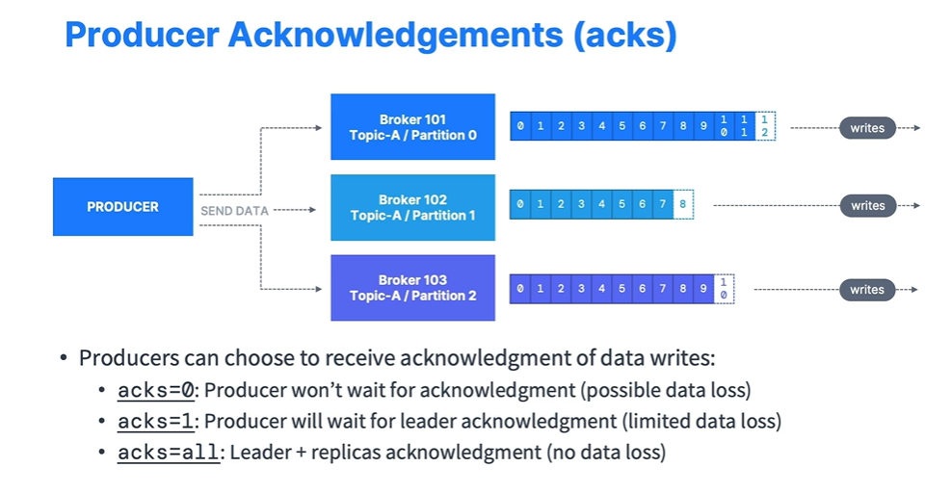

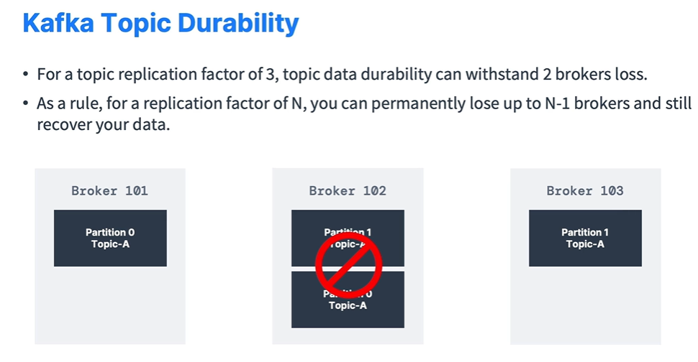

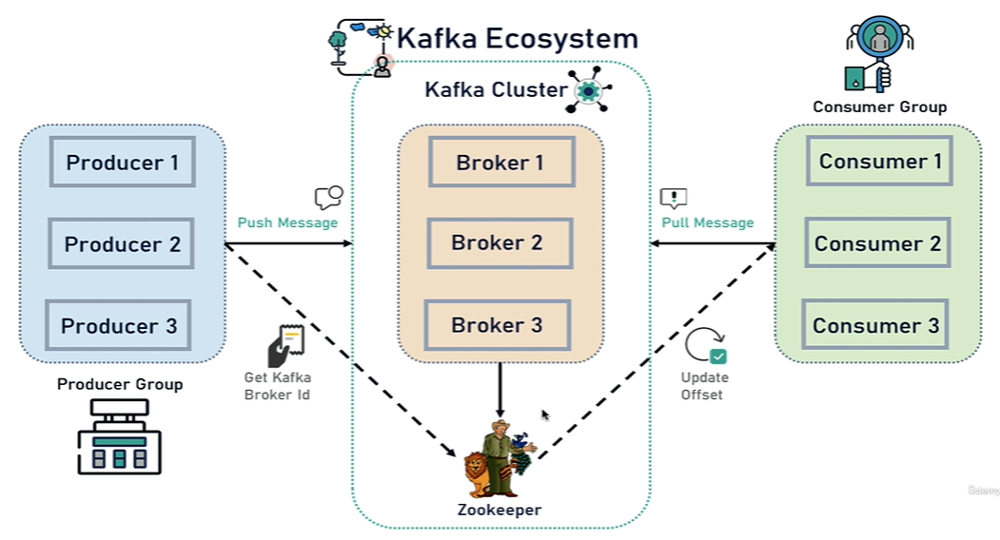

Here, Zookeeper manages all the Kafka Brokers in a cluster. Kafka act as a fault tolerance meaning if one Broker shuts down then, Kafka uses other Brokers to manage entire cluster.

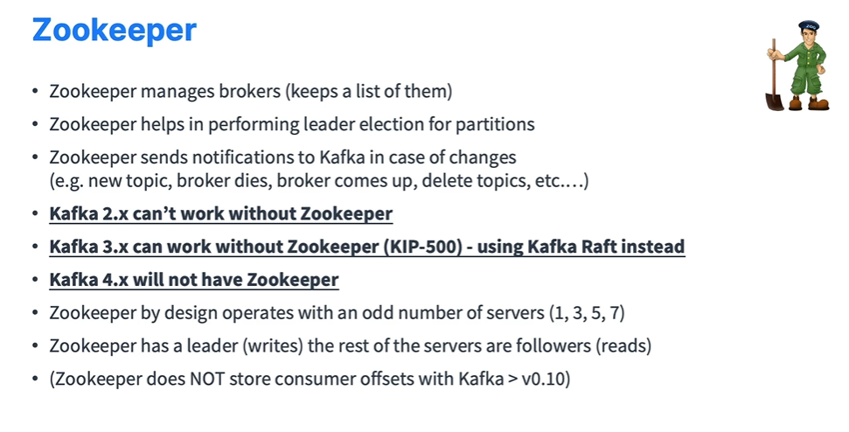

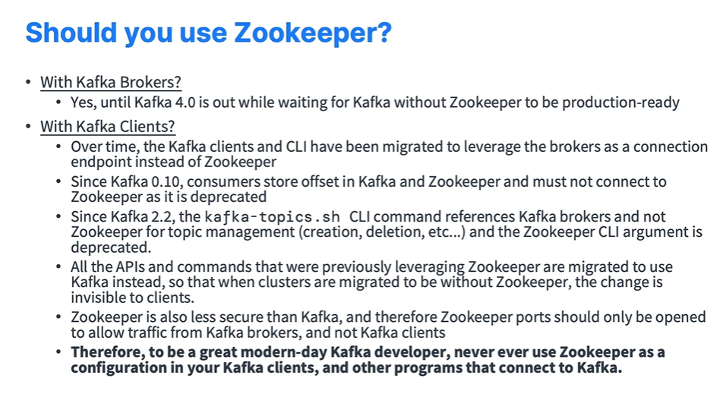

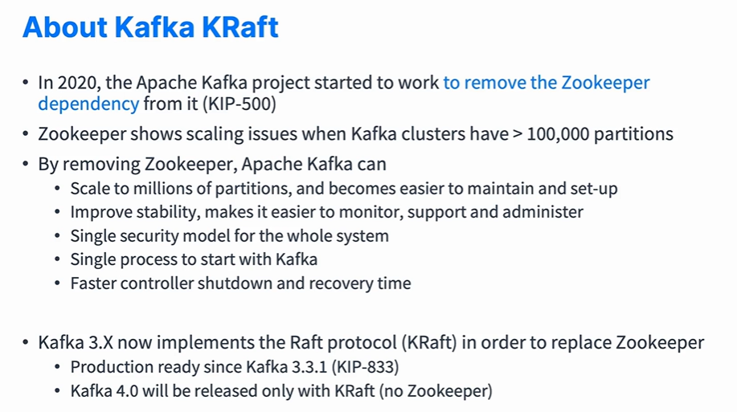

1. **Setup and Installation:**

<https://www.conduktor.io/kafka/starting-kafka/>

* 1. **Get Kafka:**

à [Download](https://www.apache.org/dyn/closer.cgi?path=/kafka/3.4.0/kafka_2.13-3.4.0.tgz) the latest Kafka release and extract it.

* 1. **Start The Kafka Environment:**

à **NOTE:** Your local environment must have **Java 8+** installed.

à Apache Kafka can be started using ZooKeeper or KRaft. Let’s see ZooKeeper configuration first.

à First of all, lets setup the path where you want to store your Kafka logs and snapshots.

* Open zookeeper.properties file in config folder then change path of dataDir for example dataDir =C:/tools/kafka/zookeeper-data
* Open server.properties file in config folder then change path of log.dirs for example log.dirs=C:/tools/kafka/kafka-logs
* Also note that to run Kafka server you need to add your listener port in server.properties file for example listeners=PLAINTEXT://localhost:9092

à After, Run the following commands to start all services in the correct order:

* Start the ZooKeeper service

Windows: .\bin\windows\zookeeper-server-start.bat .\config\zookeeper.properties

Mac: bin/zookeeper-server-start.sh config/zookeeper.properties

à Open another terminal session and run:

* Start the Kafka broker service

Windows: .\bin\windows\kafka-server-start.bat .\config\server.properties

Mac: bin/kafka-server-start.sh config/server.properties

à Once all services have successfully launched, you will have a basic Kafka environment running and ready to use.

à Let’s see KRaft configuration.

* Windows: .\bin\windows\kafka-storage.bat random-uuid

Mac: bin/kafka-storage.sh random-uuid

* Copy generated uuid for example: XNndOM7xRbaRUsJTcoHTAw
* Windows: .\bin\windows\kafka-storage.bat format -t uuid -c .\config\kraft\server.properties

Mac: bin/kafka-storage.sh format -t uuid -c config/kraft/server.properties

* Start the Kafka broker service

Windows: .\bin\windows\kafka-server-start.bat .\config\kraft\server.properties

Mac: bin/kafka-server-start.sh config/kraft/server.properties

* 1. **Create a Topic to Store Event:**

à Windows: .\bin\windows\kafka-topics.bat --create --topic topic-name --bootstrap-server localhost:9092

à Mac: bin/kafka-topics.sh --create --topic topic-name --bootstrap-server localhost:9092

* 1. **Write Some Events into The Topic:**

à Windows: .\bin\windows\kafka-console-producer.bat --topic topic-name --bootstrap-server localhost:9092

à Mac: bin/ kafka-console-producer.bat --topic topic-name --bootstrap-server localhost:9092

>hello world

>topic demo

// Once complete press CTRL + C and Press Y

* 1. **Read The Events:**

à Windows: .\bin\windows\kafka-console-consumer.bat --topic topic-name --from-beginning --bootstrap-server localhost:9092

à Mac: bin/ kafka-console-consumer.bat --topic topic-name --from-beginning --bootstrap-server localhost:9092

>hello world

>topic demo

// Once complete press CTRL + C and Press Y

1. **Spring Boot + Kafka:**
   1. **Add Kafka Dependency:**

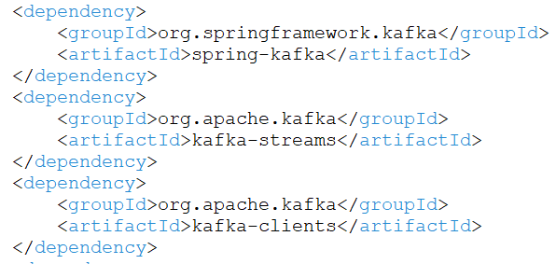

* 1. **Configure Kafka Producer and Consumer in Application Properties:**

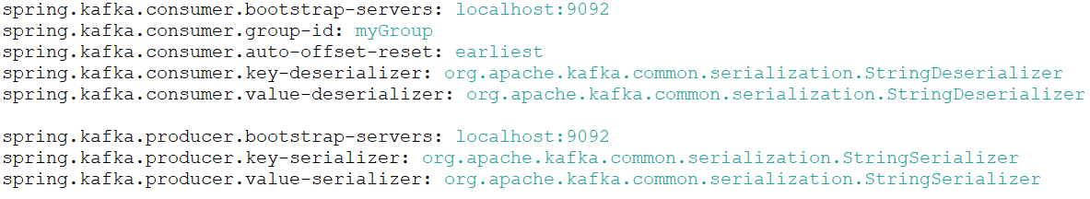

* 1. **Create Kafka Topic:**

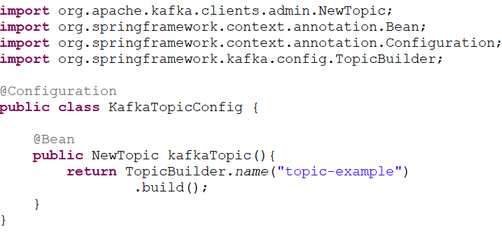

* 1. **Create Kafka Producer:**

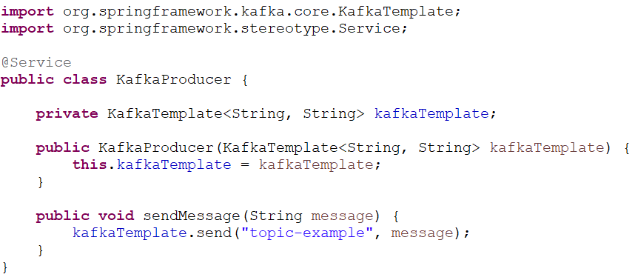

* 1. **Create REST API to Send Message:**

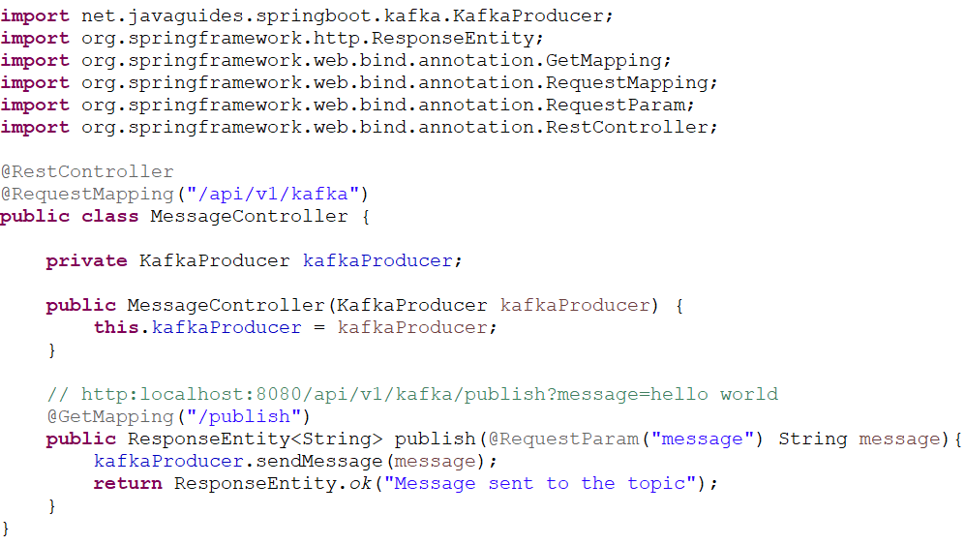

* 1. **Create Kafka Consumer:**

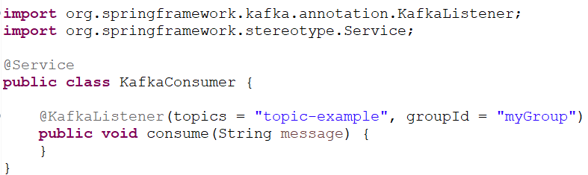

* 1. **Kafka for JSON:**

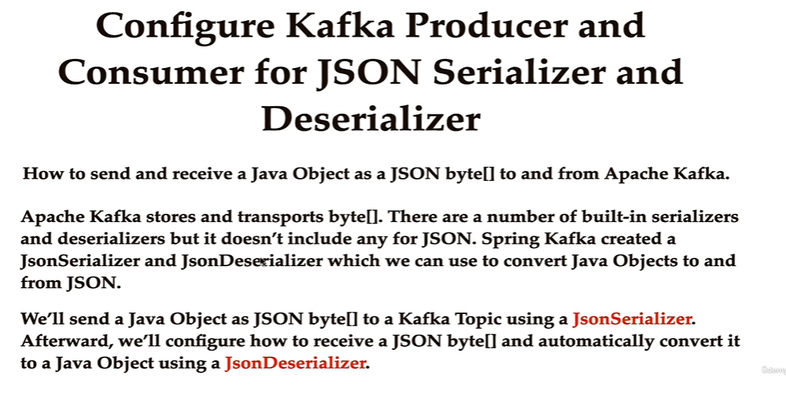

* 1. **Configure Kafka Producer and Consumer in Application Properties:**

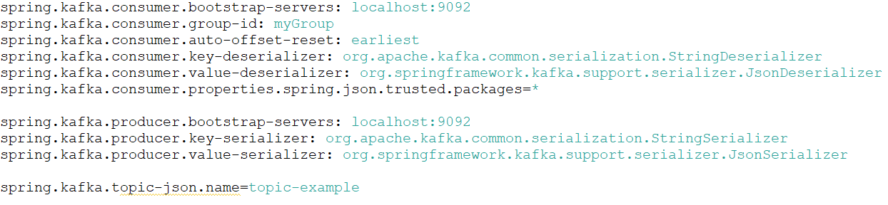

à Create POJO Class:

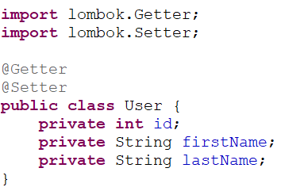

à Create Topic:

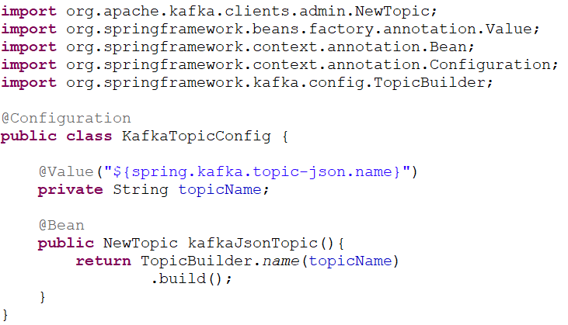

à Producer:

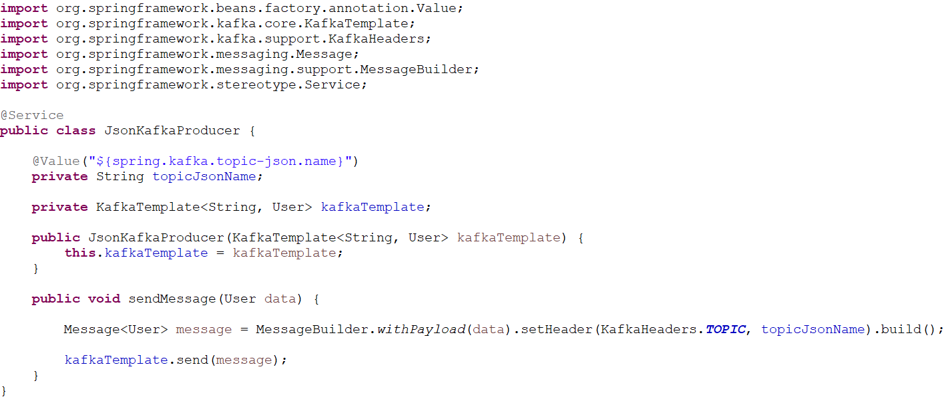

à Rest Controller:

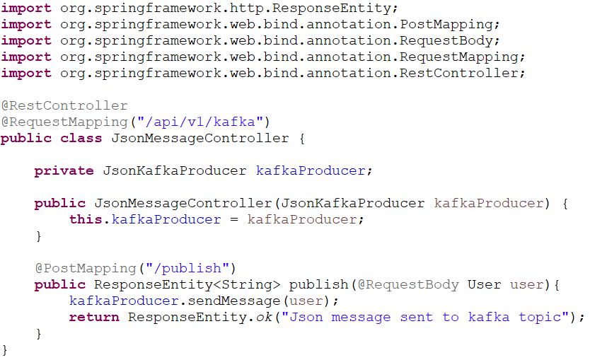

à Consumer:

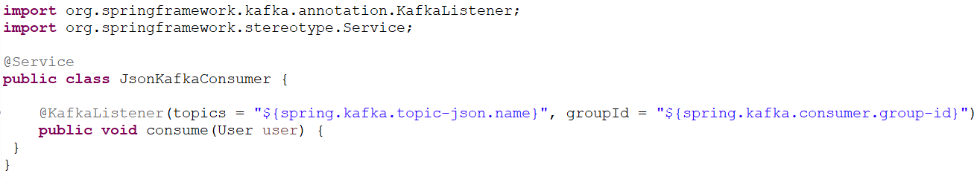

1. **Event Driven Architecture:**

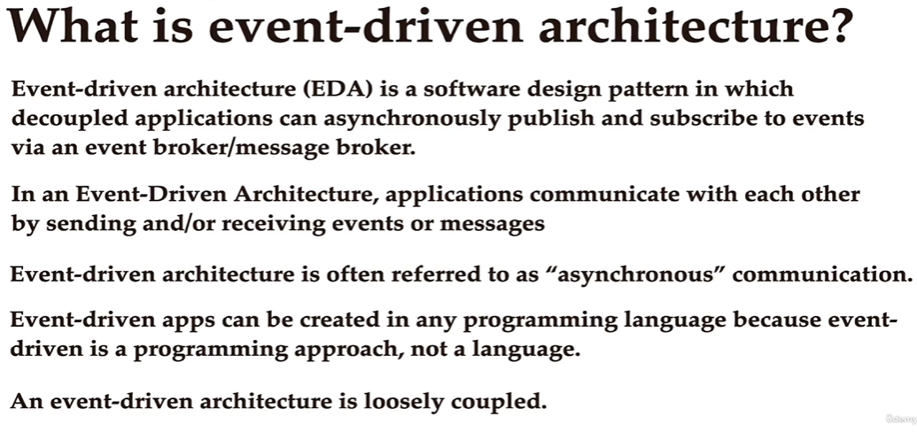

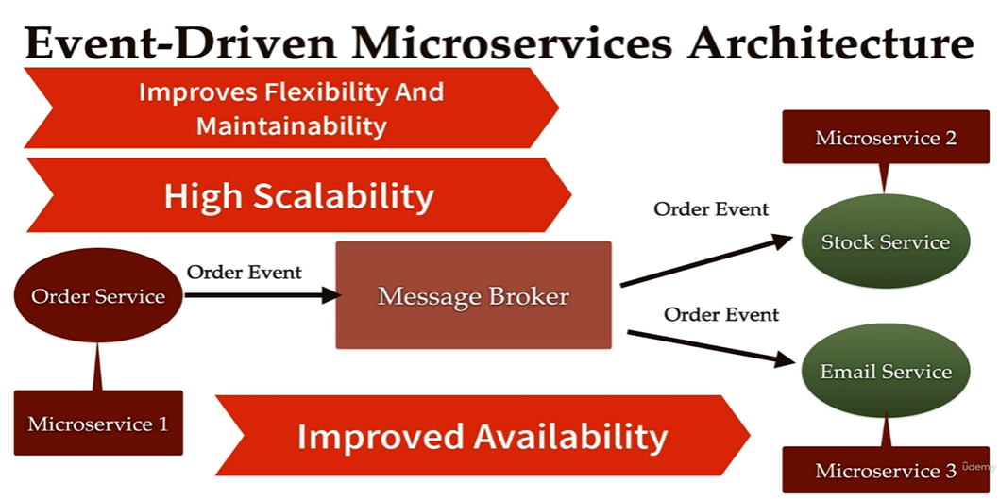

à Other Developers API:

1. Kafka Connect: solves external source to Kafka and Kafka to external sink data transmission.
2. Kafka Streams: Solves transformations from Kafka to Kafka. (One topic to another)
3. Schema Registry: Helps using Schema in Kafka. (Validation of data coming from producers KSQL)

à Partitions Count and Replication Factor:

The two most important parameters when creating a topic. They impact performance and durability of the system overall.

* Each partition can handle a throughput of a few MB/s (measure it for your setup).
* More partitions imply:
  + Better parallelism, better throughput.
  + Ability to run more consumers in a group to scale.
  + Ability to leverage more brokers if you have a large cluster
* Partitions per topic:
  + Small cluster (<6 brokers): 3 x brokers
  + Big cluster (>12 brokers): 2 x brokers
  + Adjust for numbers of consumers you need to run in parallel at peak throughput
  + Adjust for producer throughput
  + Don’t systematically create topics with 1000 partitions.
* Replication Factor:
  + Should be at least 2, usually 3, maximum 4.
  + The higher the replication factor(N):
    - Better durability of your system (N-1 broker can fail and still it will be running well).
    - Better availability of your system.
    - But more replication means higher latency and more disk space on your system.
* **Case Studies**

à Movie Flix:

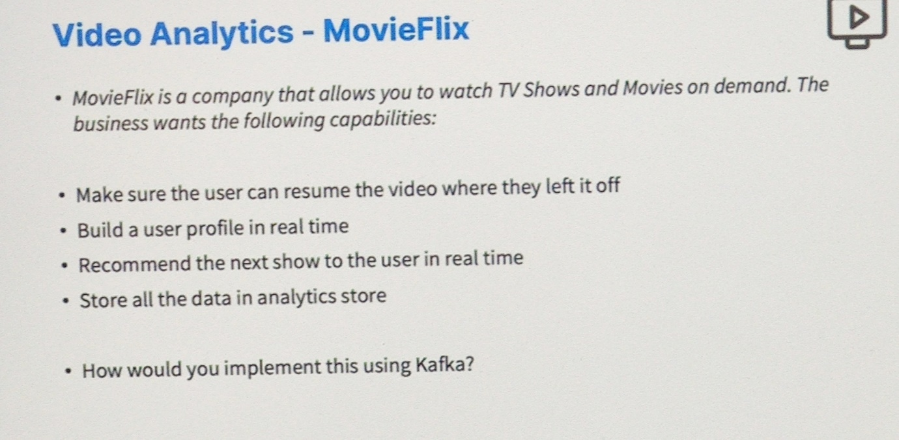

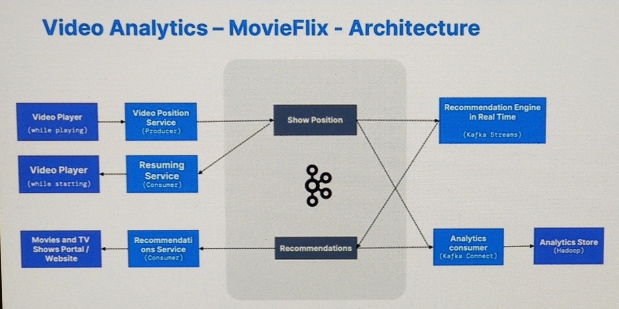

* Will have two topics in Kafka.

1. Show Position: This will store the timestamp like how far a user has watched a tv show. Will use the video position service to store the timestamp occasionally in this topic and a resuming service to consume the last stored time of the specific video from the topic and resume the video.
2. Recommendations: This will store which user watches which show and how far. Based on this data we can be able to tell which kind of shows user like and based on some data processing will recommend other shows to user. This data processing can be done by recommendation engine in real time using Kafka Streams and then the recommendation will be consumed by recommendations service.
3. All this user data will be further stored in somewhere. Here, will use Analytics consumer service that basically use Kafka Connect that help connect to the Analytic Store (Hadoop) to store the user data.

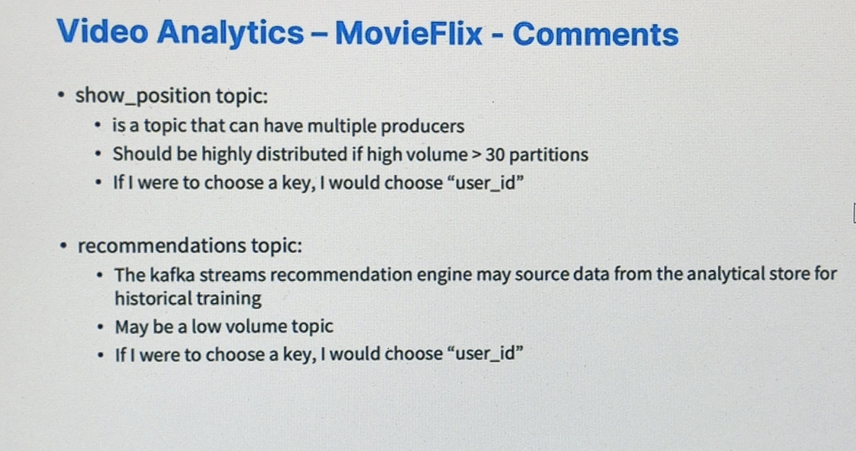

à My Social Media:

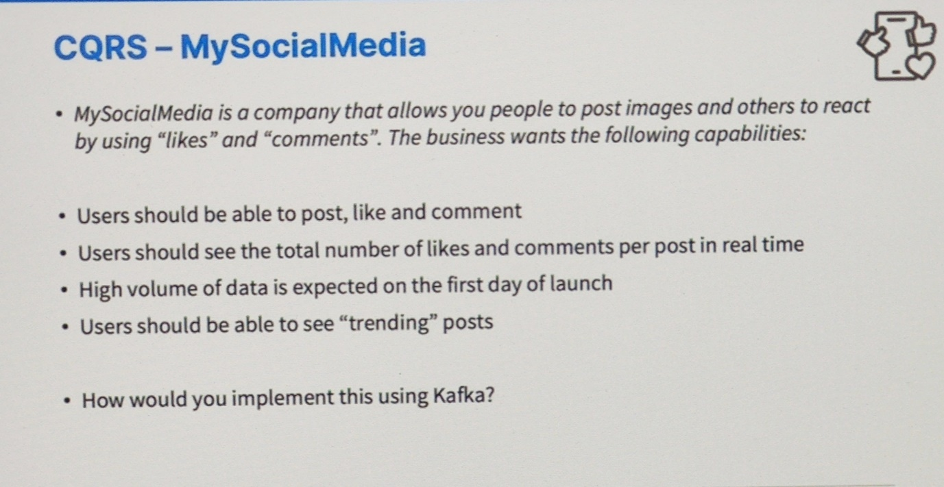

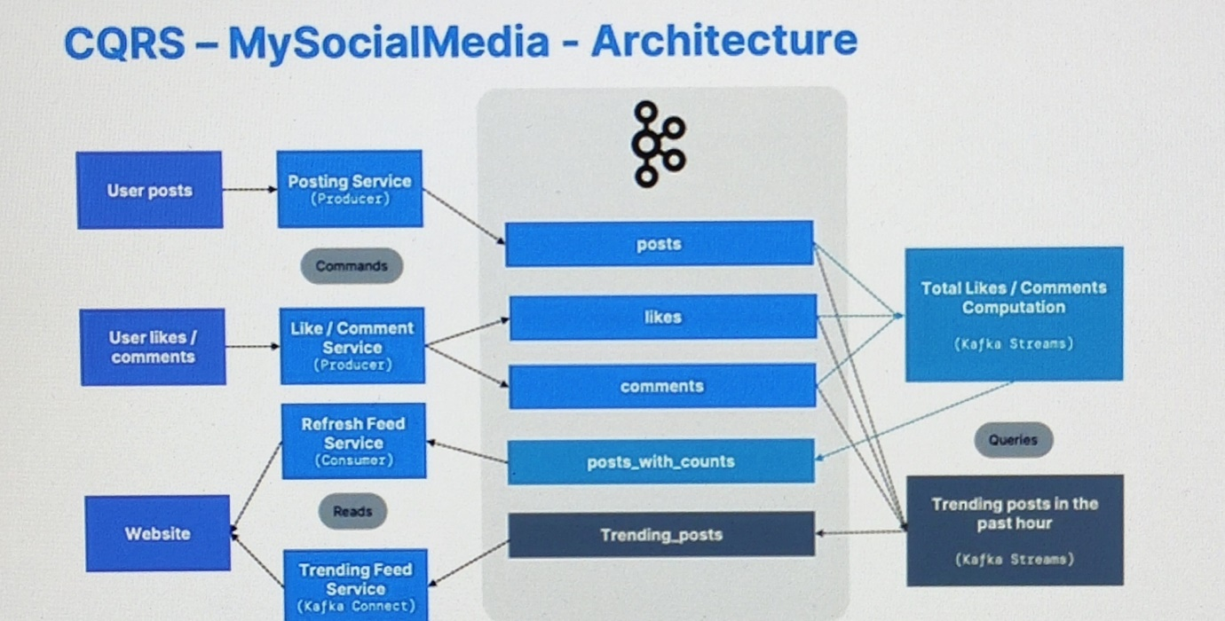

* Will have three main topics in Kafka.

1. Posts: This will store the user posts like some text, links, images, etc. Will use posting service to produce the data and store it to this topic.
2. Likes: This will store the user likes for different posts. Will use like service to produce the data and store it to this topic.
3. Comment: This will store the user comments for different posts. Will use comment service to produce the data and store it to this topic.

* Here we don’t want to increase the number of database call just to increment the likes count for a post. So will create another topic called posts with counts and perform some aggregation using Kafka Streams and store the results in this topic for each user posts.

1. Posts with Counts: This will store the total number of likes each post. Will use total likes/comments computation service that will fetch the data from all the posts, likes and comments topic, perform some aggregation and data processing using Kafka Streams and store the result back to this topic. Then, this data will be consumed by the refresh feed service and will be shown to website.
2. Trending Posts: With the same logic above we can get the trending posts.

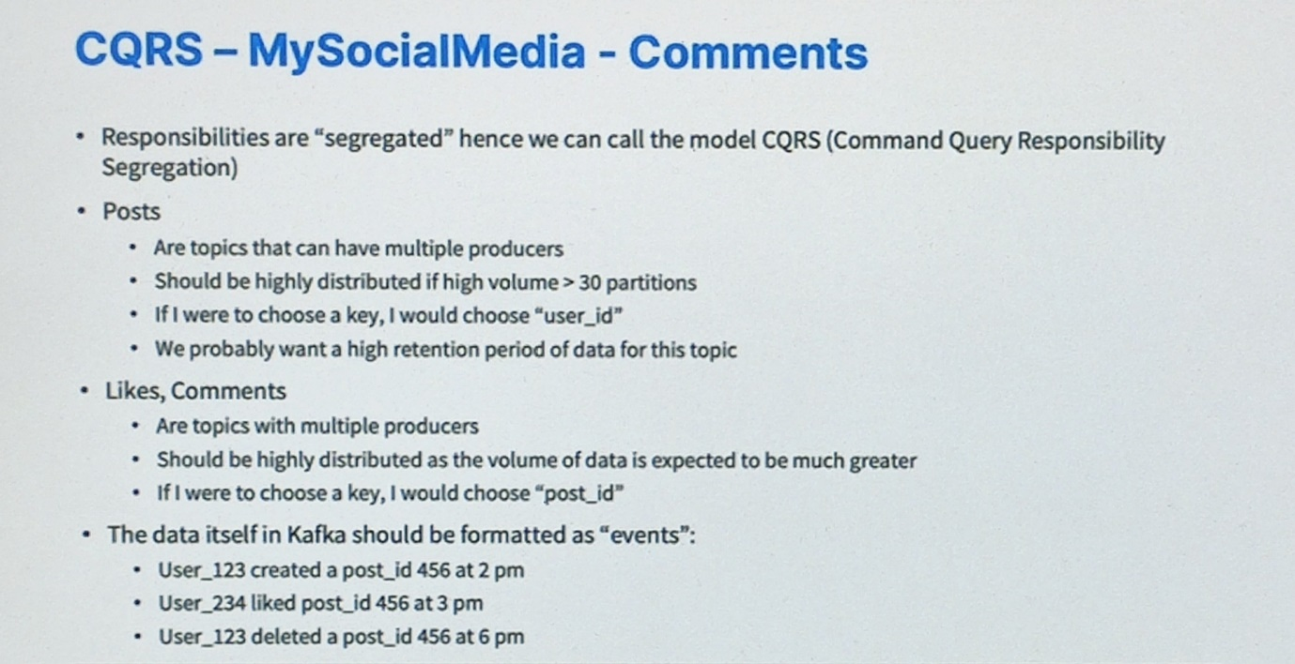

à My Bank:

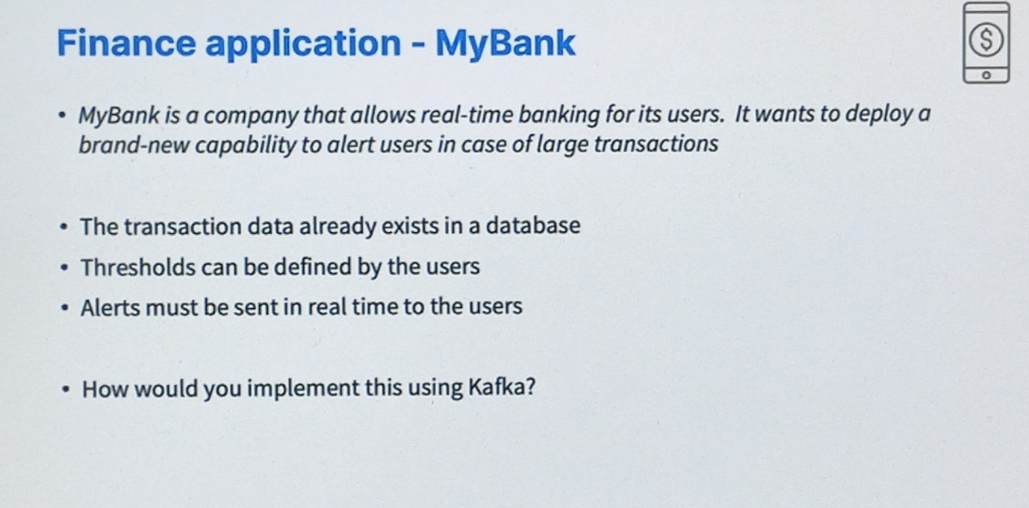

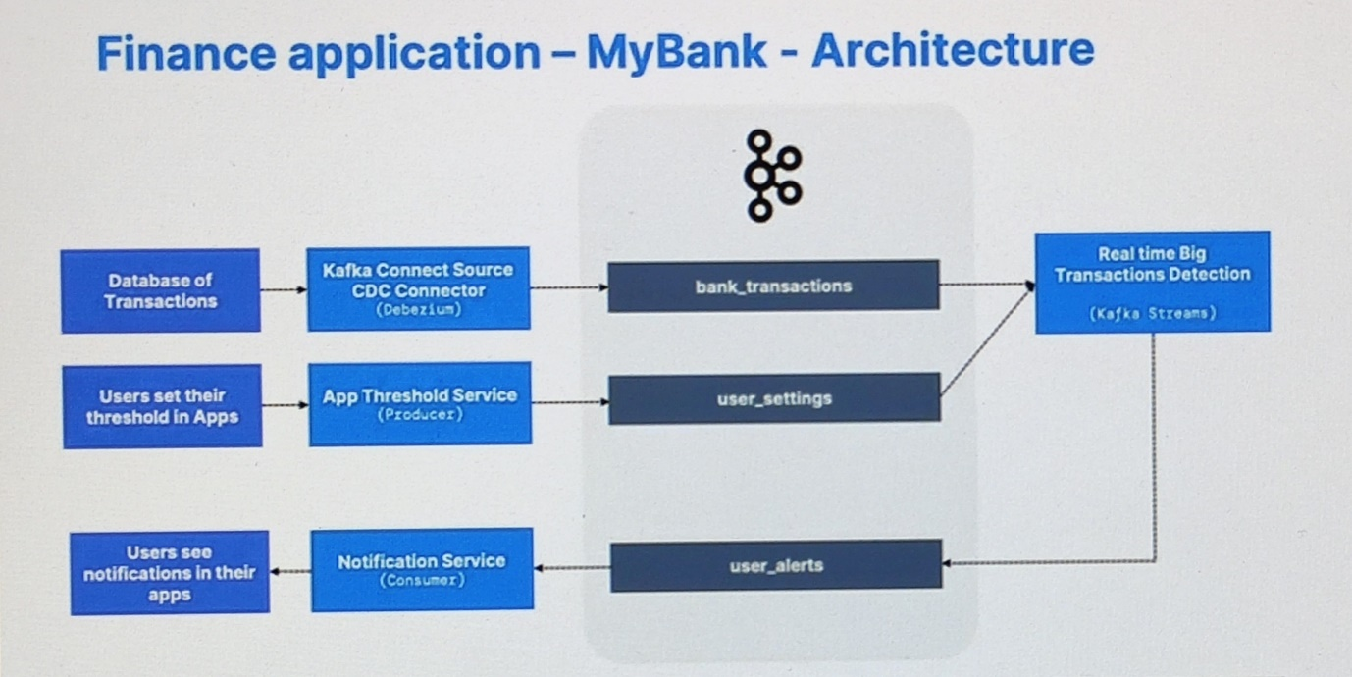

* Will have three main topics in Kafka.

1. Bank Transactions: This will store the user transaction data from the database. Will use Kafka Connect Source CDC Connector to connect with our choice of database and fetch the information from it.
2. User Settings: This will store the user settings such as minimum or maximum amount of transaction for alerts and so on. Will use app threshold service to produce the data and store it to this topic.
3. User Alerts: This will store the user’s transactional alerts and send it to user. Will use real time big transaction detection service to process data coming from bank transactions and user settings topic using Kafka Streams and store the results in the user alerts topic then that alert will be consumed by the notification service.

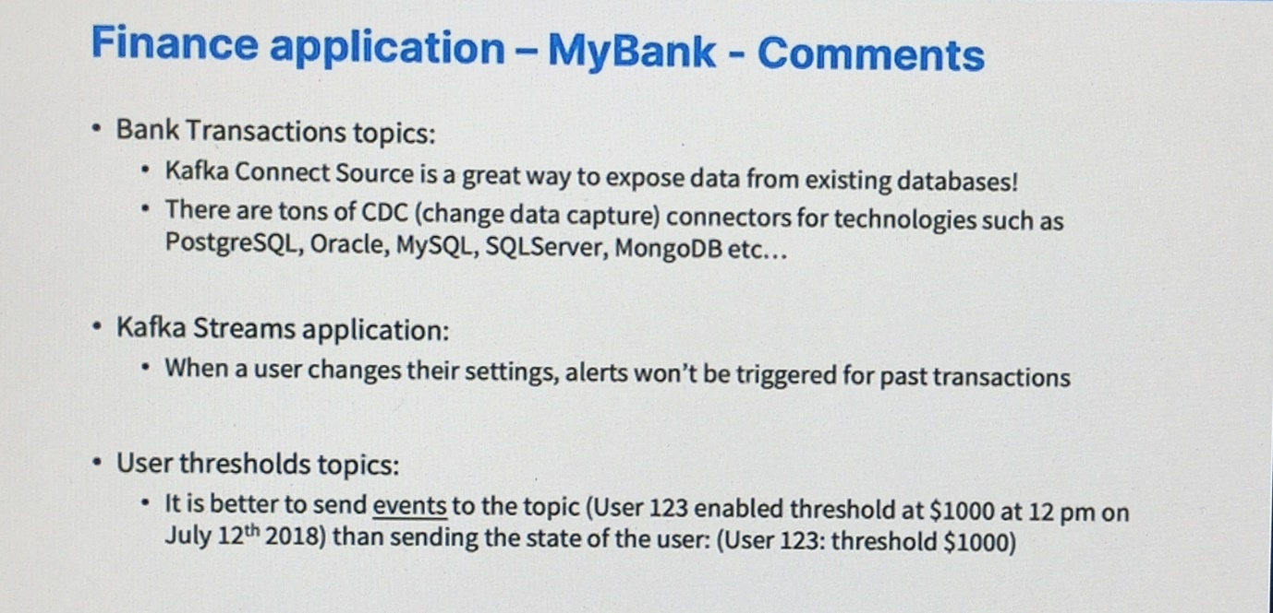

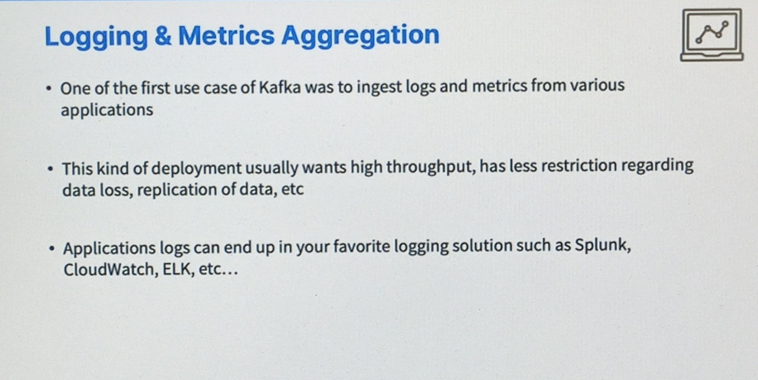

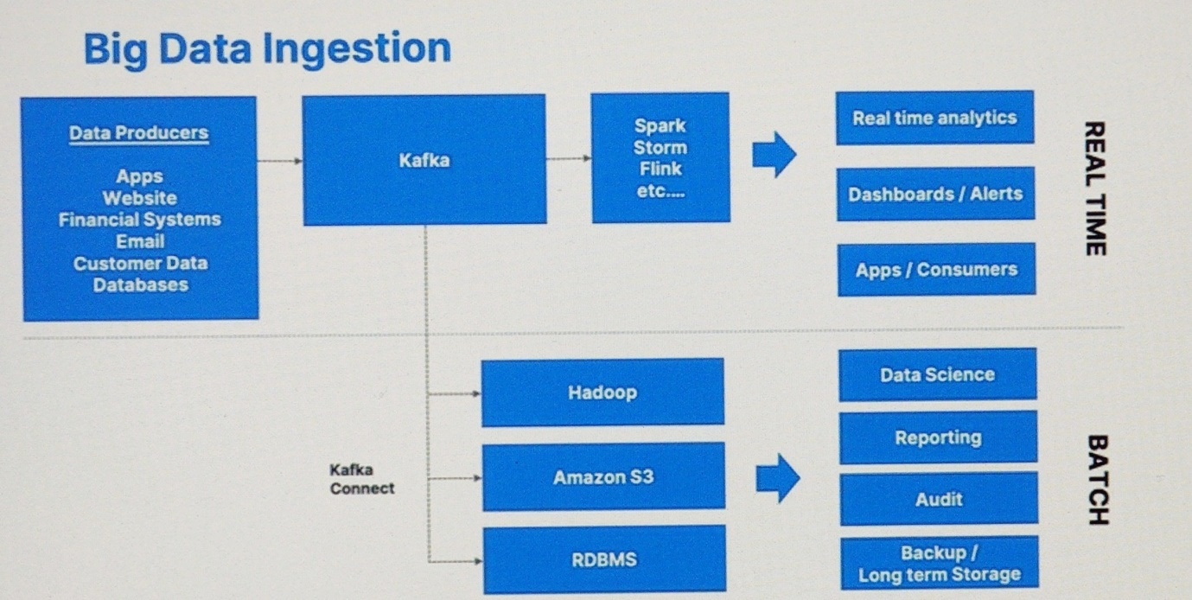

* **Advanced Topic Configuration**

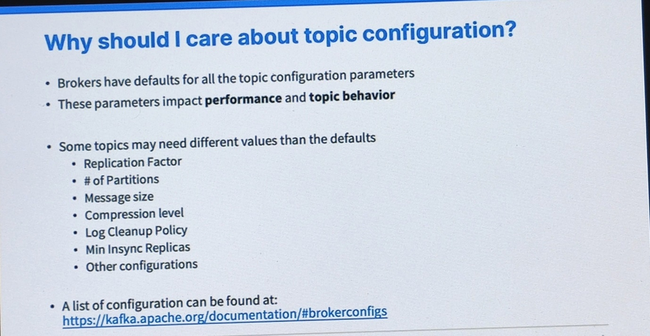

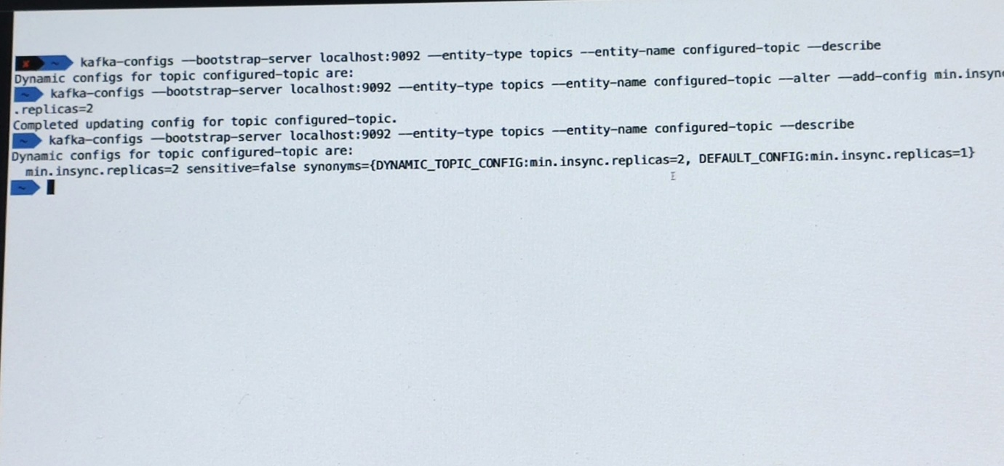

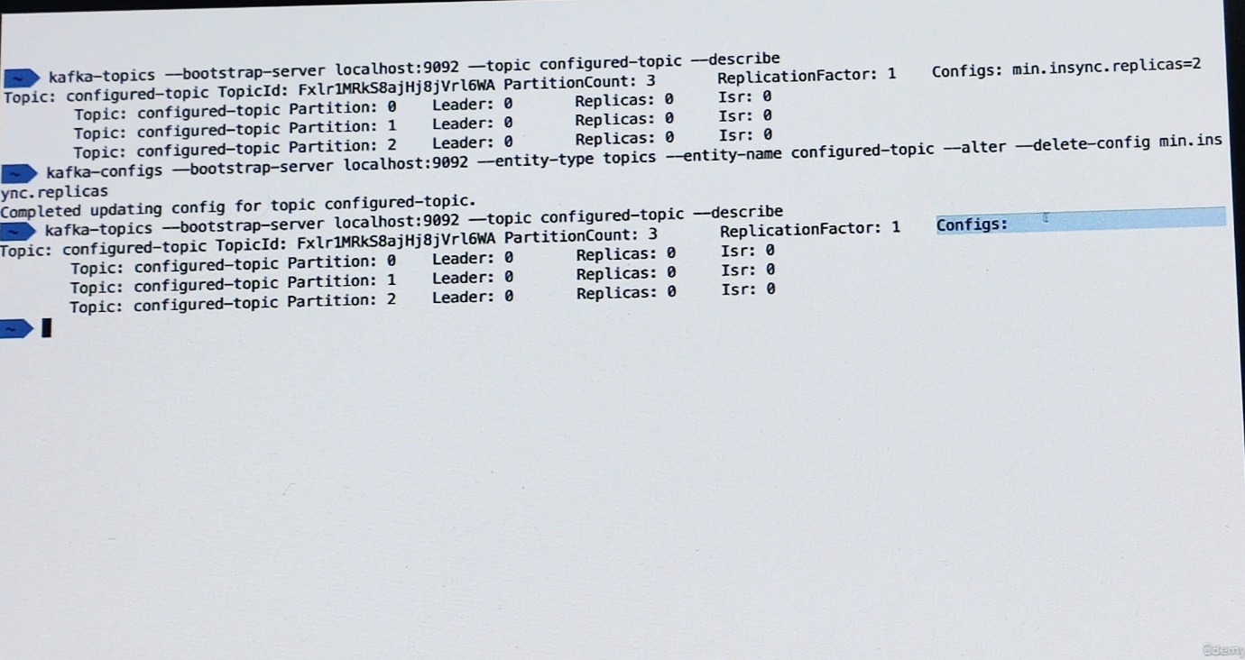

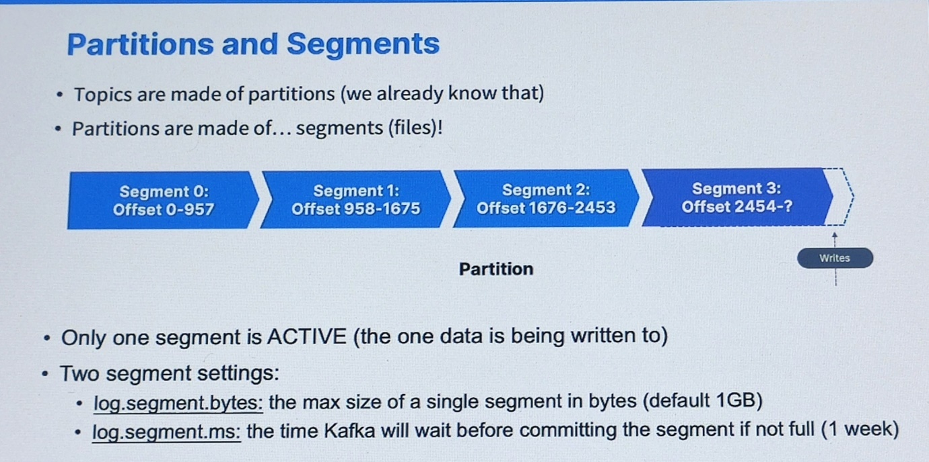

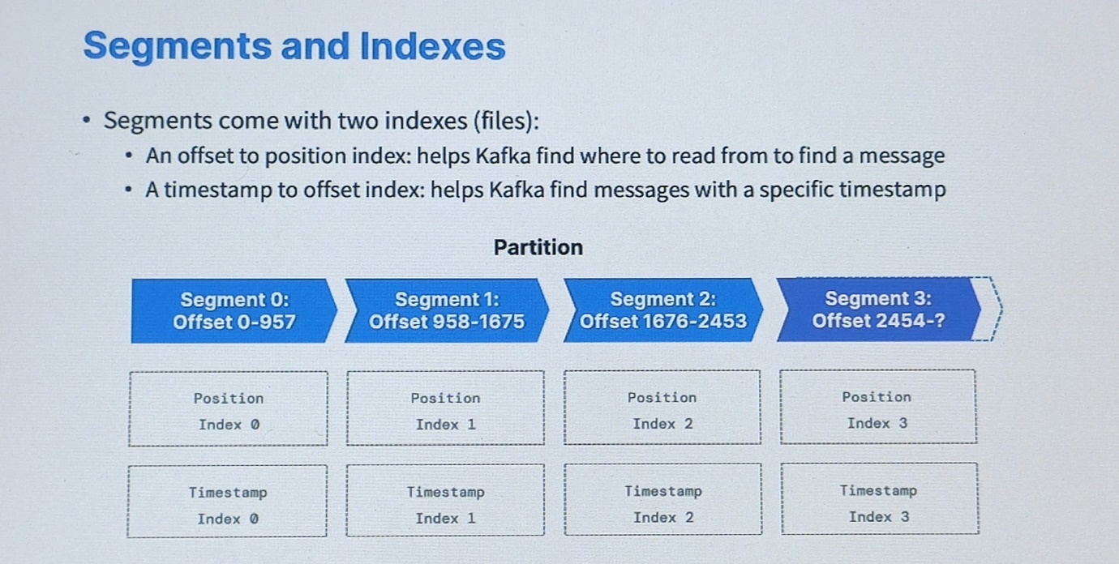

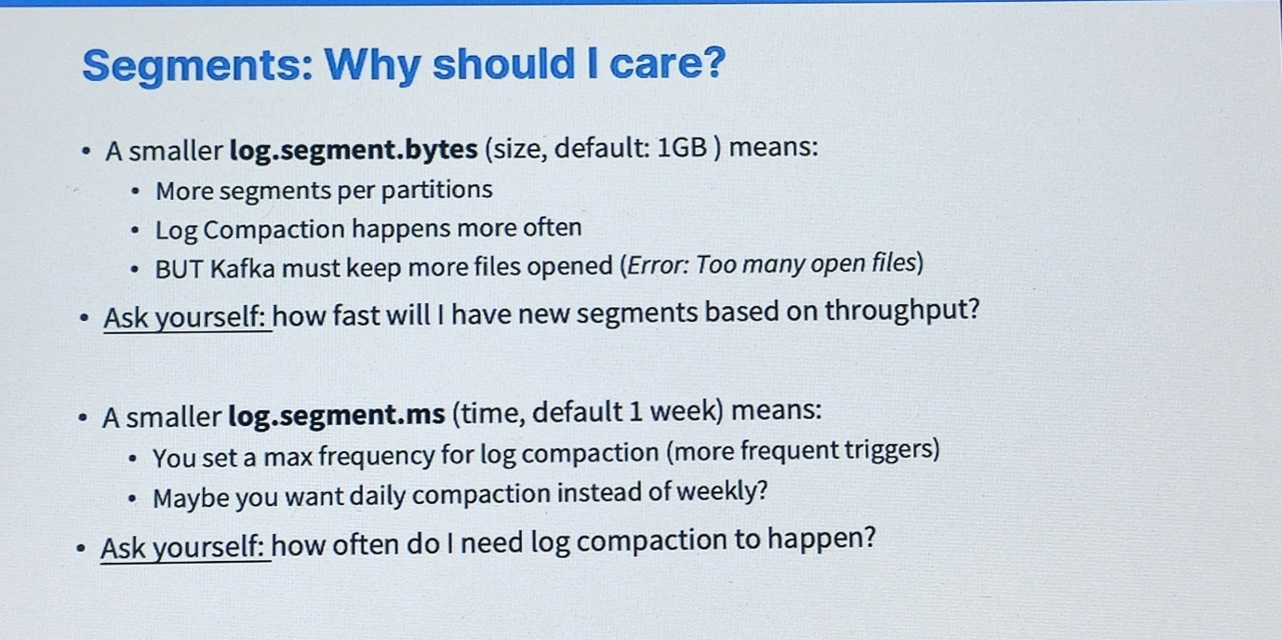

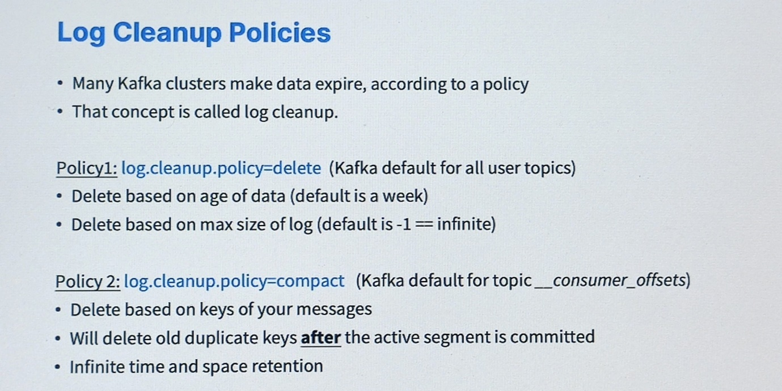

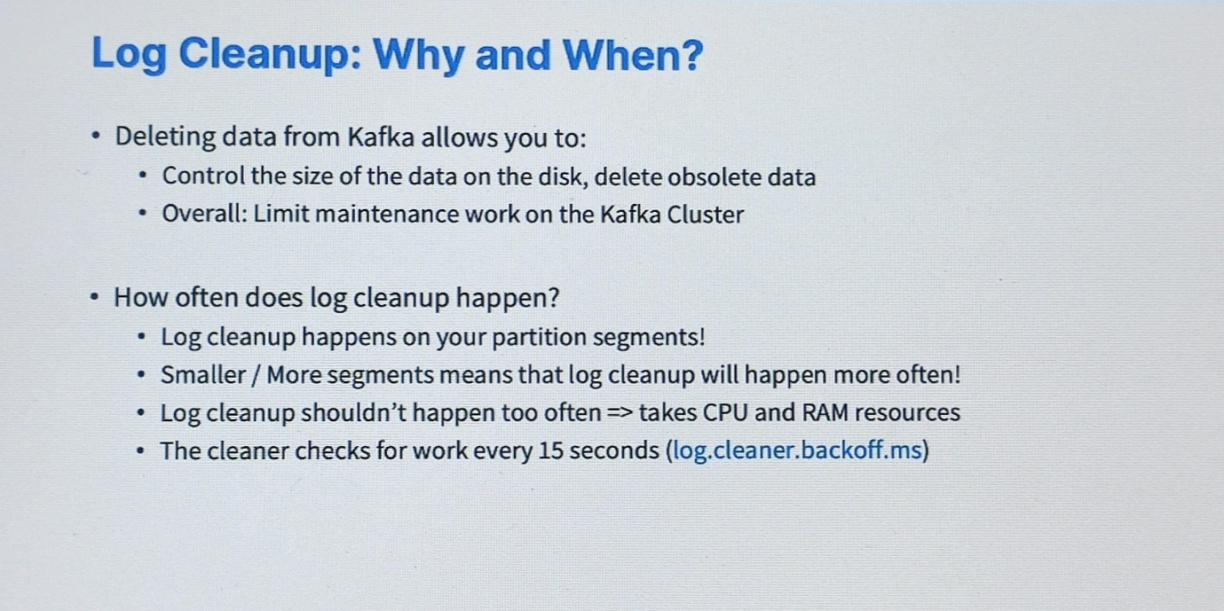

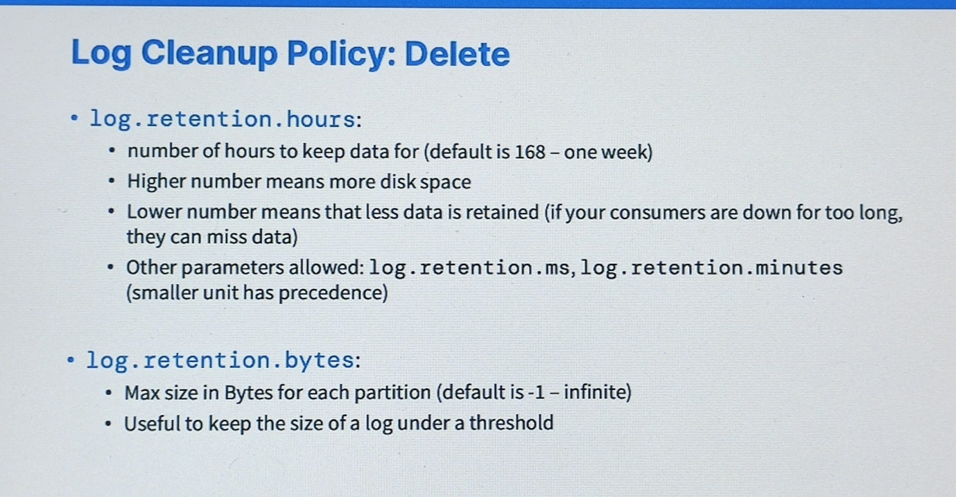

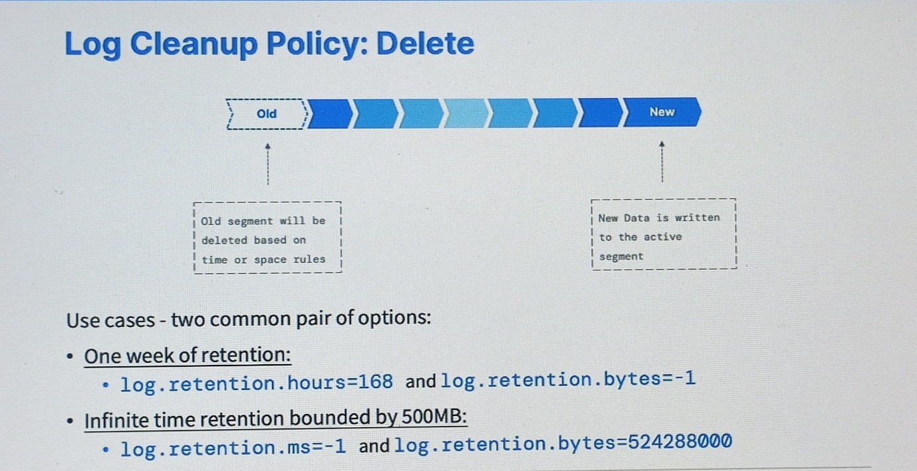

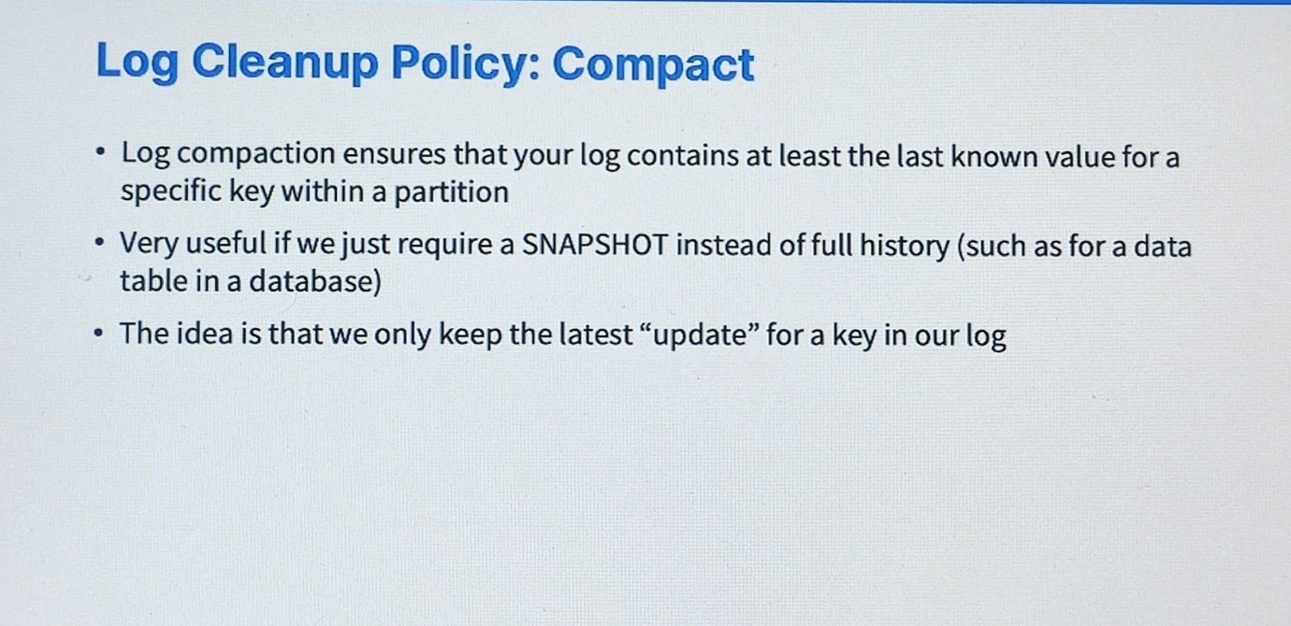

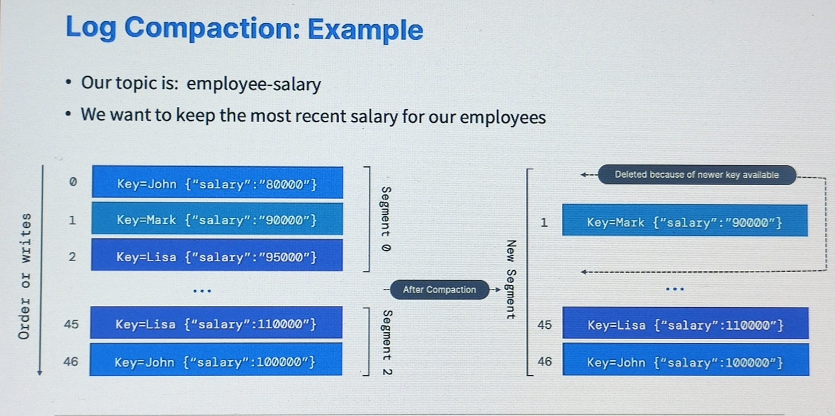

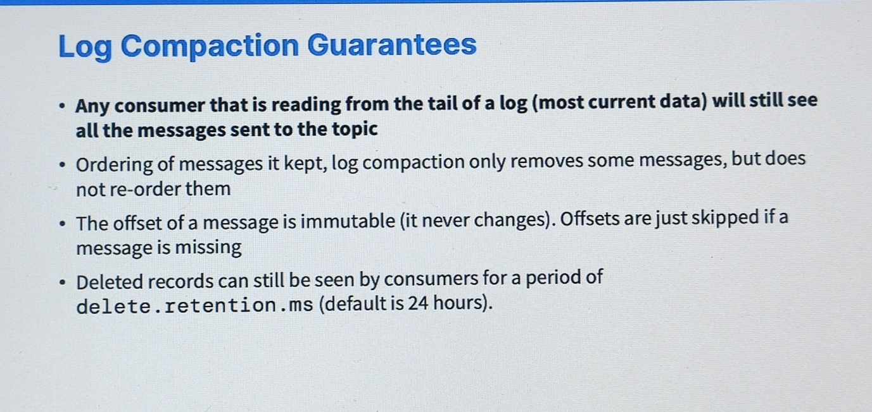

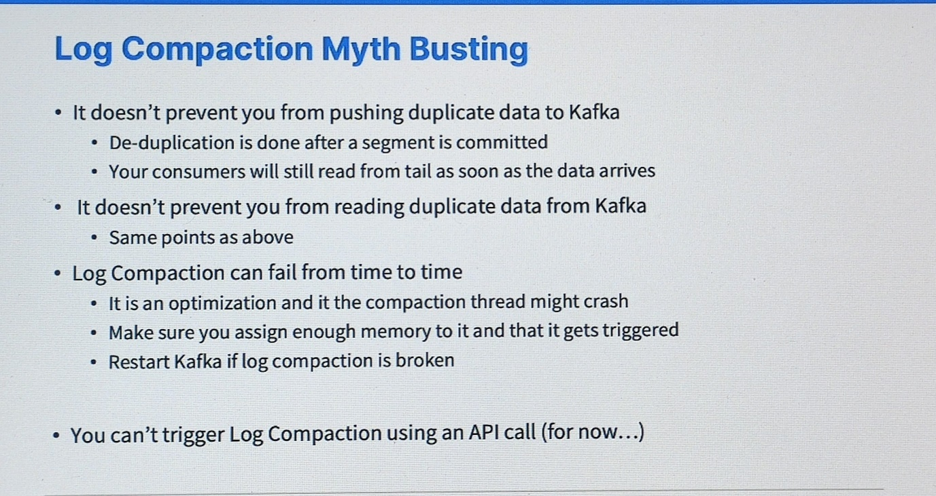

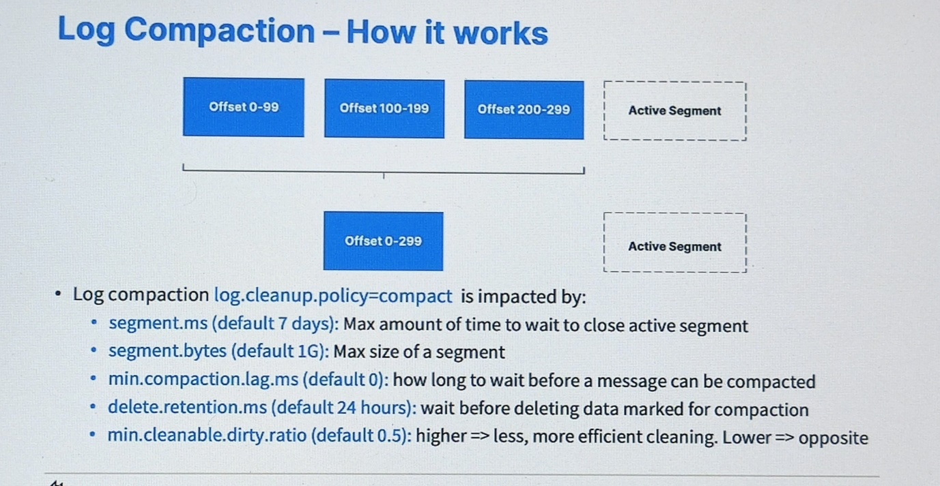

<https://www.conduktor.io/kafka/kafka-topic-configuration-log-compaction/>

